

Western University of Canada

Faculty of Engineering

MSE 2202 – Introduction to Mechatronic Design

**Team Project – Tesseract Robot**

by

Andrew Randell, Fan Kang, Lovdeep Singh, Maral Mohagheghi

Product Development File

Group 9, Prof. Naish

Date Submitted: April 11, 2018

Table of Contents

Meetings

Engineering Log-Book 4

Our Design Process 6

Final Design 24

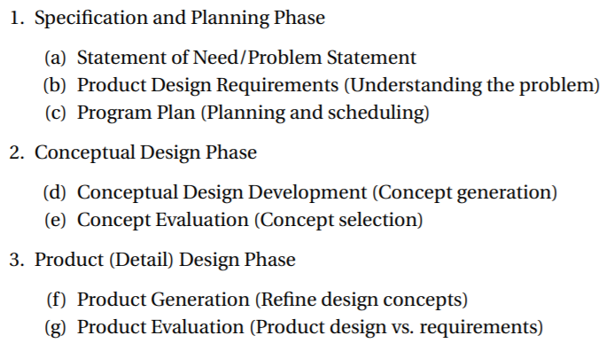

Pictures, Diagrams, Graphs

Field Diagram 9

Sketches and Models

Sketch 1 (Base) 18

Sketch 2 (Lift) 18

Sketch 3 (Towers) 19

Code and Programming

Autonomous Code 23

Product Document File

**Decision on Document File**

We decided on an electronic format over the traditional handwritten journal. We understand the latter is standard in engineering, but find that an electronic format saved on a cloud-based service will ease communication amongst the team and make the journal more accessible to members.

In order to maintain traditional aspects of an engineering notebook, we decided to save each page as a read-only PDF file and have any additional annotations made in red font. This simulates the permanent aspect of using pen in a paper notebook.

Our Design Process

**Specification and Planning**

In this process, we analyze the challenge objectives and identify design problems that we expect to face with given limitations.

**Conceptual Design**

We research design options through the use of multiple source and attempt to implement this knowledge into the development of a design. We create sketches outlining every aspect of our design and analyze the strengths and weaknesses of each. We combine the best features of each design and create more sketches. We analyze these to decide on a final product. This includes deciding on how our previously developed ideas will be implemented. We create detailed build sketches, CAD models, and simple prototypes to figure out the best way of going about each section of our design.

**Product Design**

We take the finalized approach to each section of our design and work towards compositing these into a final product. This involves a great deal of problem solving as we need to take into account space consumption, balance, structural integrity, and successful interaction between all parts. This may be revisited during the next stage of our design process if problems arise.We also begin to test and practice controlling the functions of our design. Autonomous routines and specific navigating strategies are also taken into account. Final application experiences and reflections are also considered.

**Specification and Planning**

**Problem Statement**

Create an autonomous system that locates and retrieves a tesseract and places it under the pyramid that is emitting the correct signal.

**Meeting Minutes #1**

**Date: February 15, 2018**

**Agenda:**

* Define/ Understand Problem Statement
* Break down the problem into smaller tasks

**Discussion:**

1. **Problem Statement**
   1. create an autonomous system that locates and retrieves a tesseract and places it under the pyramid that is emitting the correct signal.
2. **Step by Step breakdown**

* Locate the cube
* Retrieve the cube
* Locate the correct pyramid
* Pick up pyramid
* Place pyramid over cube

1. **Concerns:**

* The robot’s motion might not be able to effectively move over the conduits
  + Friction calculations required to select appropriate motors and wheels
  + Unsteady motion over the conduits may result in the loss of the location of the pyramid or tesseract when locating them
* Cube might be pushed over the wall during cube retrieval

**To be completed:**

1. Brainstorm possible strategies for locating the tesseract
2. Compile several solutions for tesseract and pyramid retrieval
3. Research possible sensors that could be used in the products

**Product Design Requirements**

**Meeting Minutes #X**

**Date: February xx, 2018**

**Agenda:**

* Analyze field setup and discover specific problems that we feel we must overcome in our robot design.
* Define design requirements
* Begin sketching implementations of ideas and analyzing the plausibility and effectiveness of these designs.
* Generate a list of questions to be answered both internally and externally.

## **Discussion**

**Analyzing Field Setup**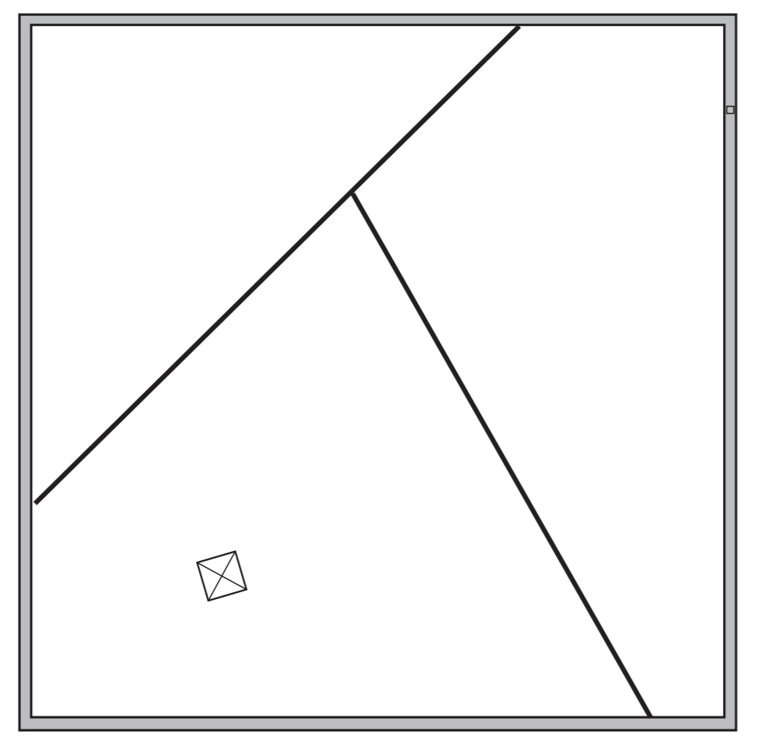









* Encoders, ultrasonic range finders and other sensors that give the robot a sense of placement will be vital for an autonomous period within the open field.

**Questions**

|  |  |
| --- | --- |
| **Question** | **Approach** |
| How precise is pyramid hole size compared to cube? | Eugen |
| Angle of pyramid | Eugen |
| How much of our bot can be laser cut / 3d printed (within budget?) | Eugen |
| How do we use suction cups with arduino? | Google |
| Friction coefficients with lexan? | Google |
| Hall effect sensors | Google |
| Photosensitive (IR) sensors | Google |
| Ultrasonic sensors | Google |
| Can we use outsourced motors | Naish |
| What are the specs on the VEX sensors Prof. Naish has for us | Owl |

## **To be completed:**

* Analyze the implementation of various designs and begin discussing best choices for first prototype.
* Discuss financial budget and parts that are essential for building such designs.

**Design Requirements/ Specifications:**

Considering the Problem Statement a list of consumer needs was compiled. These consumer needs then lead to a set of engineering requirements that were used to set up a Quality Function Deployment (QFD).

The main goal of the robot being designed is to reliably and consistently locate and place the tesseract under the correct pyramid. To do this each of the tasks the problem is broken down into must be completed effectively. More specific requirements were then generated for each part of the task after the task was broken down into multiple steps. These task specific requirements were used to evaluate the validity of the concepts generated during the concept generation process. The following sub-requirements were generated:

1. being able to navigate the course without being hindered by the conduits
   1. Move straight forwards or backwards
   2. Do not slip over the conduits
   3. Be able to turn over the conduits
2. Locating and retrieving the tesseract
   1. Consistently locate the tesseract no matter the location
      1. modular
   2. Accurately locates the tesseract
   3. Does not push the tesseract somewhere unreachable during the locating process
   4. Does not lose/ drop the tesseract while navigating the course after retrieval
3. Locating the correct pyramid and retrieving it
   1. Consistently reads the signal from each pyramid
   2. Consistently selects the correct pyramid
   3. Does not lose the signal after locating the pyramid
   4. Effectively pick up the pyramid
   5. Do not drop the pyramid

**Program Plan**

**Work Plan**

|  |  |
| --- | --- |
| **Week** | **Deliverable** |
| February 15 | Stuff to do for reading week, general direction discussion |
| February 22 | Prelim ideas, CAD of arm concepts, research |
| March 1 | First design review ready, tasks assigned for prototype |
| March 8 | Work on prototype build, most parts sourced |
| March 15 | Work on prototype build and coding |
| March 22 | Second design review ready, prototype complete |
| March 29 | Final parts laser cut or otherwise created |
| April 5 | Robot complete |
| April 11 | Report complete |

**Conceptual Design**

**Meeting Minutes #2**

**Date: February 24, 2018**

**Agenda:**

* Discuss strategies for locating the tesseract
* Discuss designs for cube and pyramid retrieval
* Discuss sensors and actuators that could possibly be used in the design

**Discussion:**

1. **Strategies for locating the tesseract**

* Move to the center of the field and spin slowly and scan all four walls looking for the cube
  + - Hall effect sensors have quite a short range so if this strategy is to be used, sensors with a longer range should be used.
* Go around the entire field and scan the entire length of the wall until the cube is located
  + - Hall effect sensors could be used
    - Must be mind full of not knocking the cube off the wall just before locating it as we got around the wall
* Design a retrieval mechanism that picks up anything that is on the wall
  + - No need to find the cube before retrieving it
    - We would just need to know if we have the cube
      * A limit switch or hall effect sensors could be used

1. **Possible Pyramid retrieval designs**

* Each member brainstormed and sketched several ideas individually
* The ideas were looked at by all the members and the duplicates were removed
* Sketches or cad drawings of the pyramid pick up ideas are attached below

1. **Sensors:**

* A document is created for the purposes of compiling a list of possible sensors that can be used for the product
  + This document contains the name of the product, locations where the product can be sourced from, the price of the products and a link to the spec sheet for the product
  + This file will be regularly updated as possible sensors are further researched and the group strategies for completing the task continues to evolve.

**To be completed:**

1. Finalize the pyramid pick up concepts
2. Complete the required concept selection processes for the pyramid pick up (i.e. Decision matrix …)

**Conceptual Design Development**

To generate design concepts, each team member developed sketches and models for each particular task or challenge.

**Pyramid Manipulation**

**Flap Intake Mechanism Design Concept (CAD)**

The flap design with a 30 degree angle ramp based on belts and rollers in factory production lines is developed to verify if the pyramid and cube can both be manipulated with one intake mechanism, or if separate claw-type mechanisms are needed for cube manipulation.

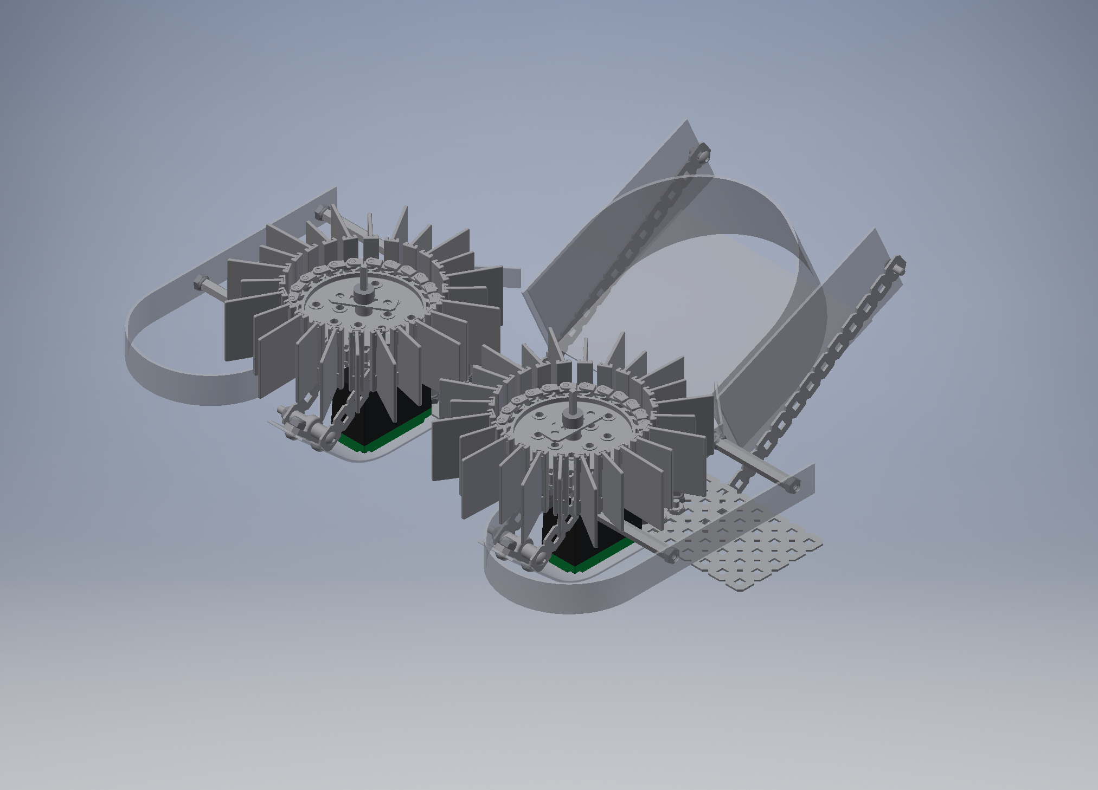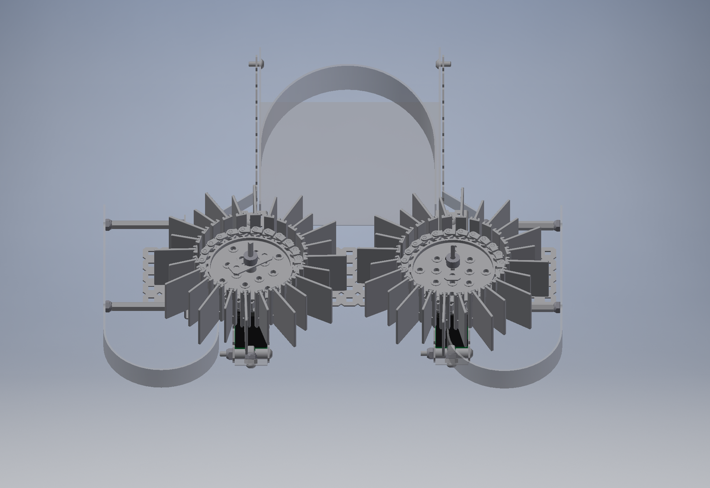

**Roller Intake Design Concept**

The pyramid roller intake aims to make direct contact with the upper walls of the pyramid, spin opposite to each other to use friction to push the pyramid into a ramp holder. Measures would need to be made to acquire the right type of material (possibly rubber) for the rollers.

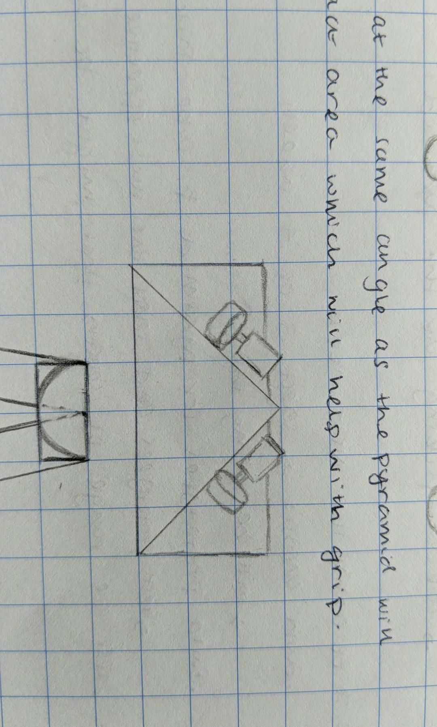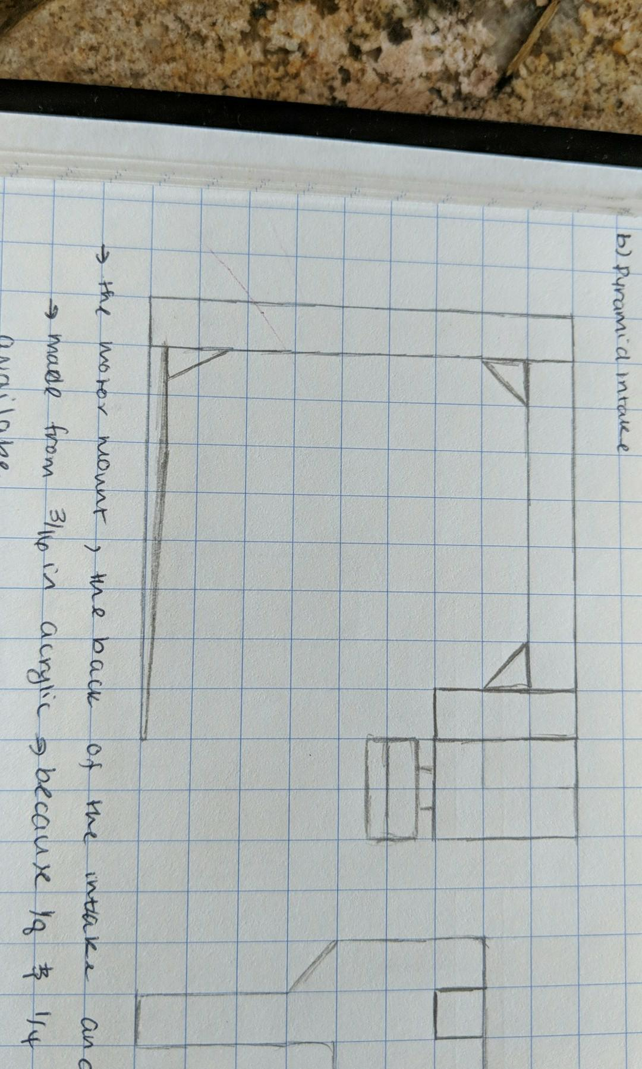

**Vertical Suction Cups**

Using a single servo, two arm links rotate to close the vertical claw onto the pyramid, at which point the suction cups push onto the pyramid and lift it. To increase the clamping force, a gear train with a larger output gear can be pursued.

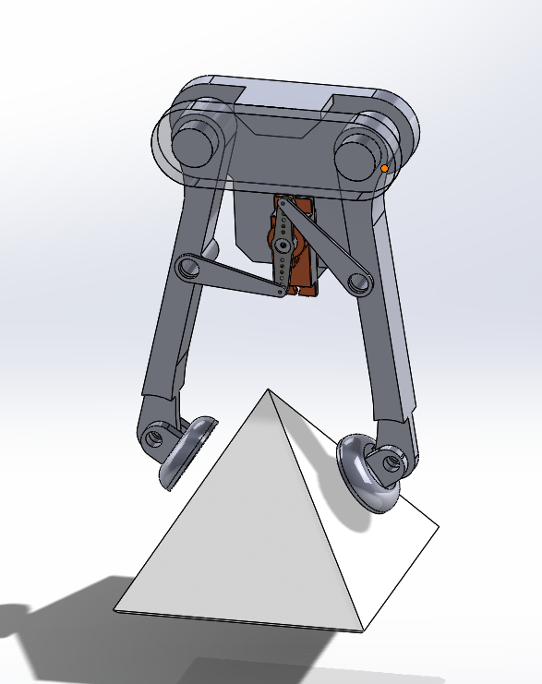

**Pyramid Storage**It was decided that having the ability to store and move the pyramid would allow for more flexibility and reliability in design. Without storage, the robot would need to have retrieved the cube and transfer it underneath the pyramid immediately after the pyramid is retrieved, which would both limit design, programming, and marketability of the product. As such, each design is able to contain and maneuver the field through the use of an elevated ramp or suction cups. **Pyramid Location**

As a design requirement is to identify the correct pyramid transmitting a code via IR, an IR sensor is necessary. In addition to searching for the pyramid through IR, an ultrasonic sensor may be used to verify the position of the pyramid.

**Meeting Minutes #3**

**Date: March 2, 2018**

**Agenda:**

* Discuss Designs for Cube retrieval
* Discuss possible chassis designs

**Discussion:**

1. **Designs for cube retrieval**

* Each member brainstormed cube retrieval methods individually
* The concepts generated by the members were examined and the duplicates were removed.
* A drawing or cad model of the concepts generated are available on the next page.
* The group originally considered modifying the pyramid retrieval mechanism to pick up the tesseract as well to simplify our design but this would require the pyramid intake to be able to become much smaller that it needs to be when intaking the pyramid. This design would also require the intake to reach above a wall.
  + - * Due to the above challenges, it was observed that although using one mechanism would decrease the number of components needed, it would increase the complexity of the intake design and lower its reliability.
* The remaining designs are as follows
  + - Magnetic Intake:
    - Arm Claw:
    - Rail Claw:
* **Note –** Depending on the design selected for cube retrieval our strategy from locating the cube might change
  + - As described in meeting minutes #2 from February 24, 2018

1. **Chassis Design**

* A four-wheel chassis design was selected over a two or three-wheel design to gain higher stability
  + This will allow the product to navigate the conduits in a more consistent and stable manner
    - A three-wheel design with a passive front wheel will be less consistent so the path of the robot would be harder to predict as it moves over the conduits
  + **Concerns:** The 4-wheel design might make it harder for the robot to turn in tight corners
* One motor controlling each side would ensure that the two wheels on one side of the robot are moving in sync and are not fighting against one another at any point. This will make the product easier to program.
* A chain can be used to drive the two wheels on each side using one motor.
  + The chain allows us to adjust the distance between the wheels to reach a balance between the consistency of the drive and the space required for the cube and pyramid mechanisms to be mounted on.
* Calculations are required to find effective and efficient motors to use.

**To be completed:**

1. Research possible motors and wheels that can be used for the drive base
2. Complete the required concept selection processes for the cube retrieval mechanism (i.e. Decision matrix …)

**Cube Manipulation**

**Magnetic Intake Design Concept**

This design involves using a rotating mechanism with various flaps attached to it. A magnet would be attached to each of these flaps. As a result the mechanism can pick up the pyramid anywhere on the wall as the robot goes around the wall. This design does not require us to know where the tesseract is. With this design we would only need to know when the tesseract is retrieved by the robot. A secondary mechanism must then be used to remove the cube from the magnet.

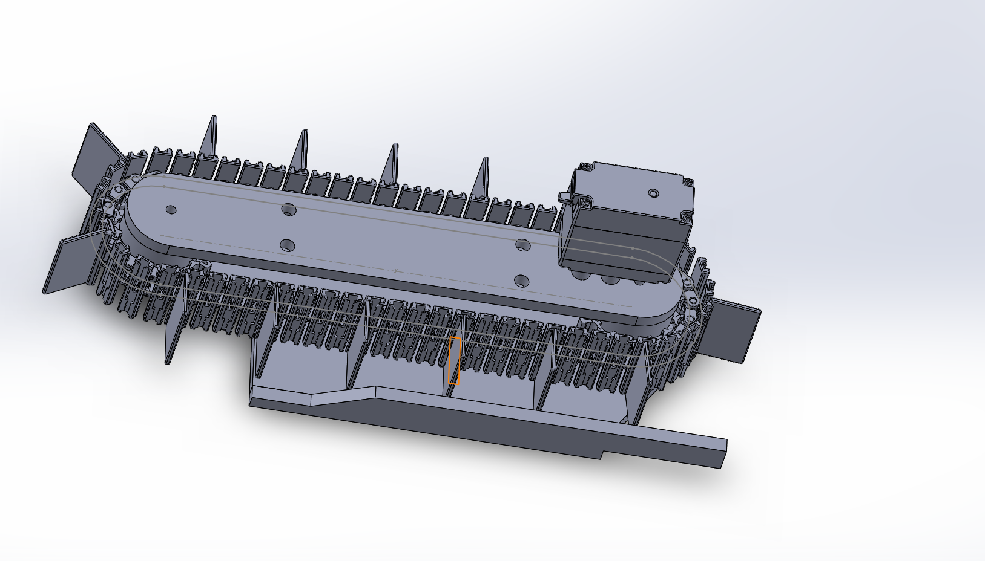

**Arm Claw**

The arm would be mounted on the robot at the same height as the wall, and can pivot to adjust for minor height deflections. The claw design is much more reliable than the intake for picking up and securing the tesseract, and the arm can rest over the wall while the robot drives along the perimeter of the arena.

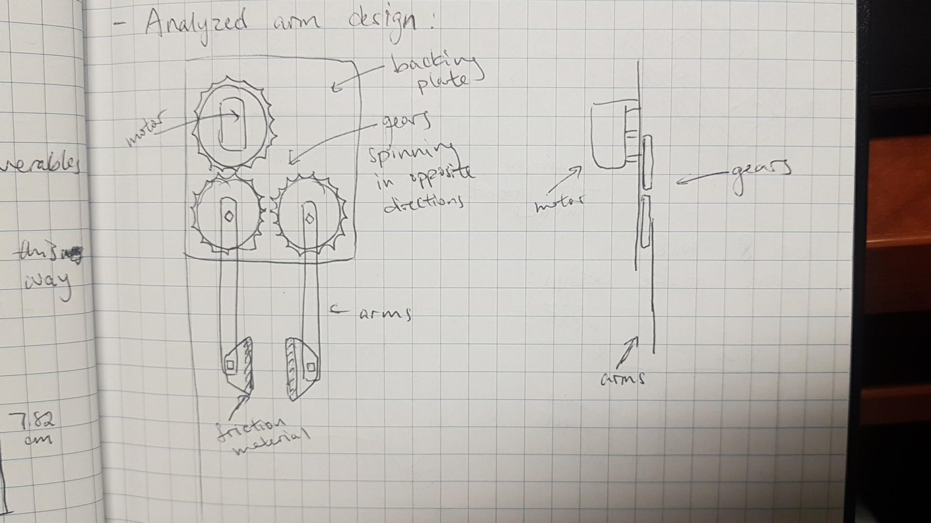

**Rail Claw:**

Utilizes the same claw design as the arm claw, but retracts and extends the claw by mounting it at the end of a rack and pinion. The tesseract would be retrieved and controlled by retracting the rack and dropping it in a funnel on the robot. This eliminated the problems of powering a motor to hold horizontal position and the tesseract bouncing randomly, increasing the reliability of the entire procedure.

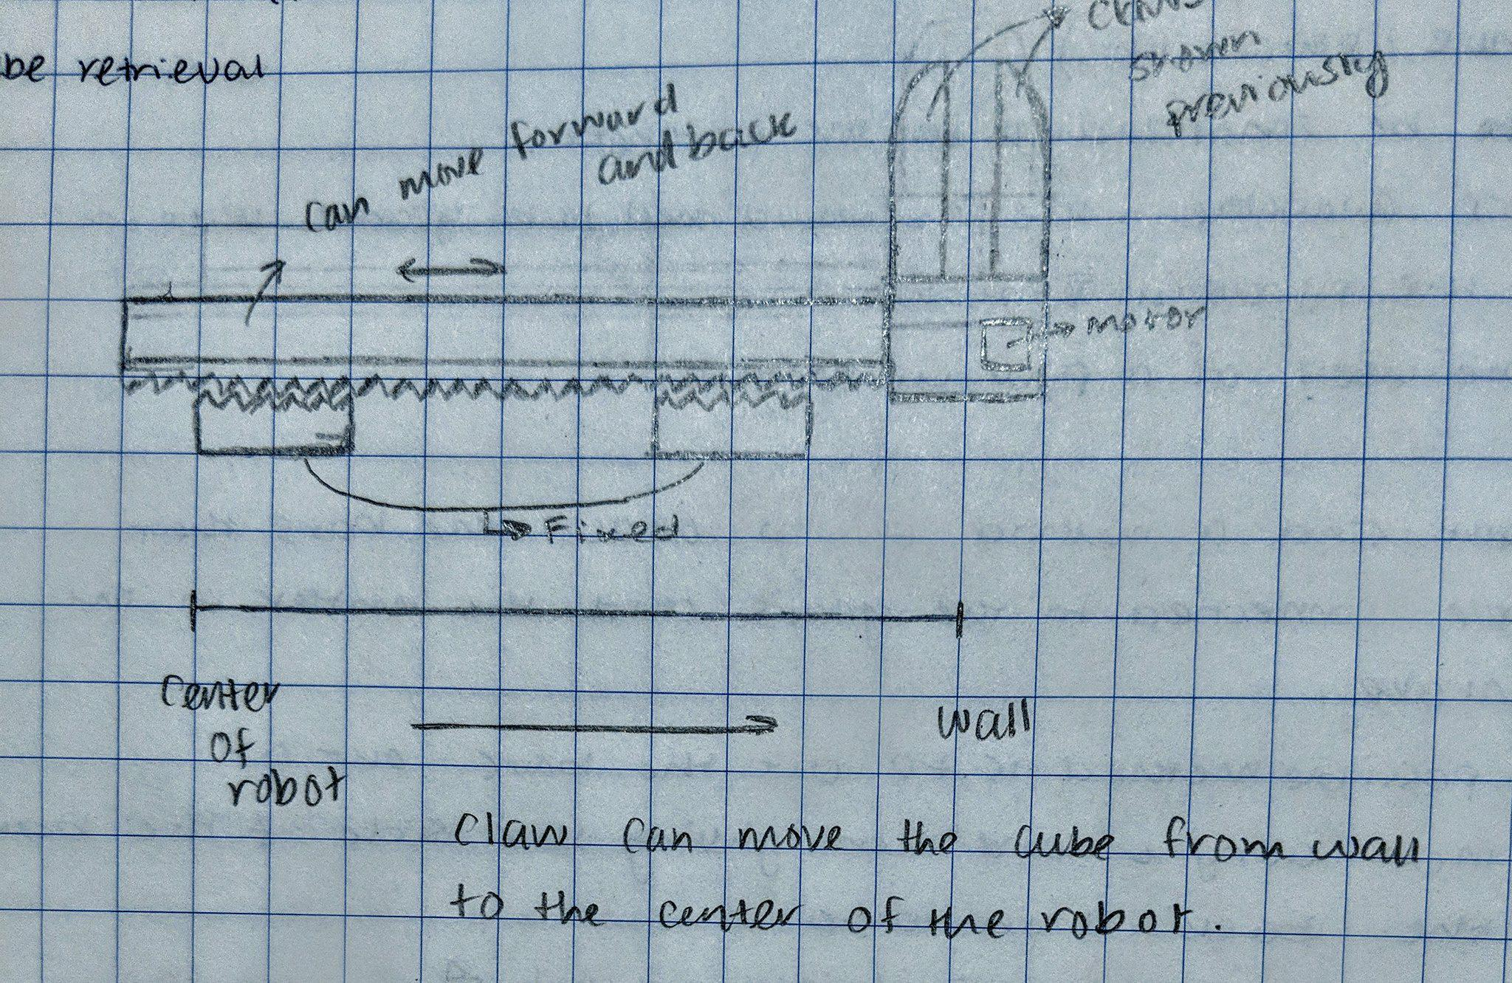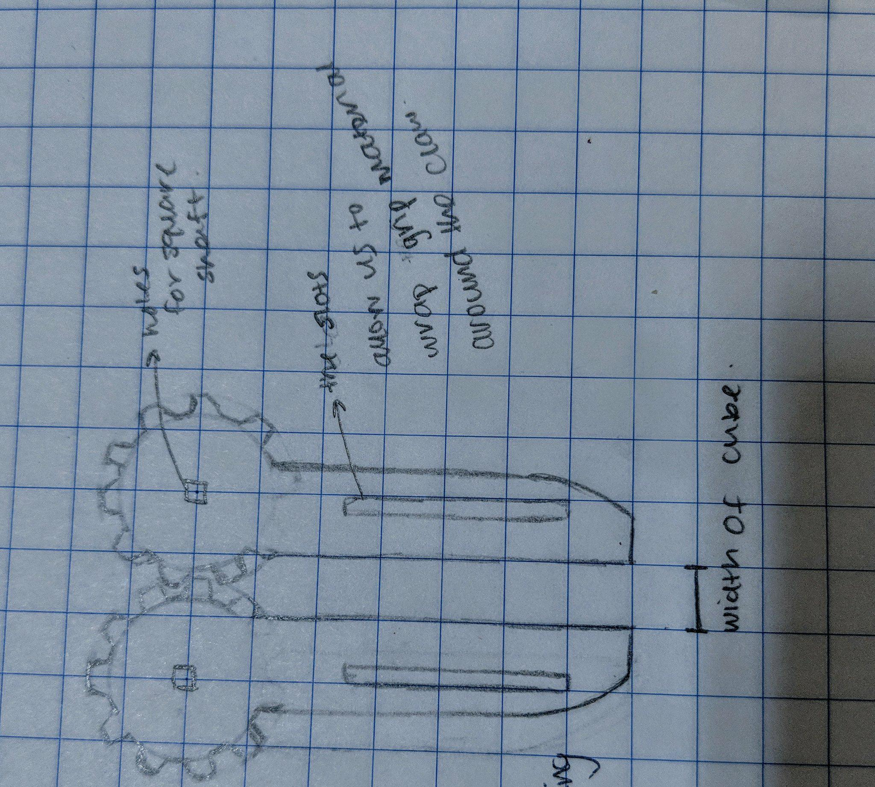

**Cube Storage and Release**

To store the cube as the robot begins to search for the pyramid, all three retrieval mechanisms are able to keep the cube inside the mechanism. To release the cube, however, the magnetic intake requires a stopper or a motorized mechanism to remove the cube from the magnets. A ramp or a funnel can be used to direct the cube to the bottom of the robot, close to the pyramid mechanism (figure below).

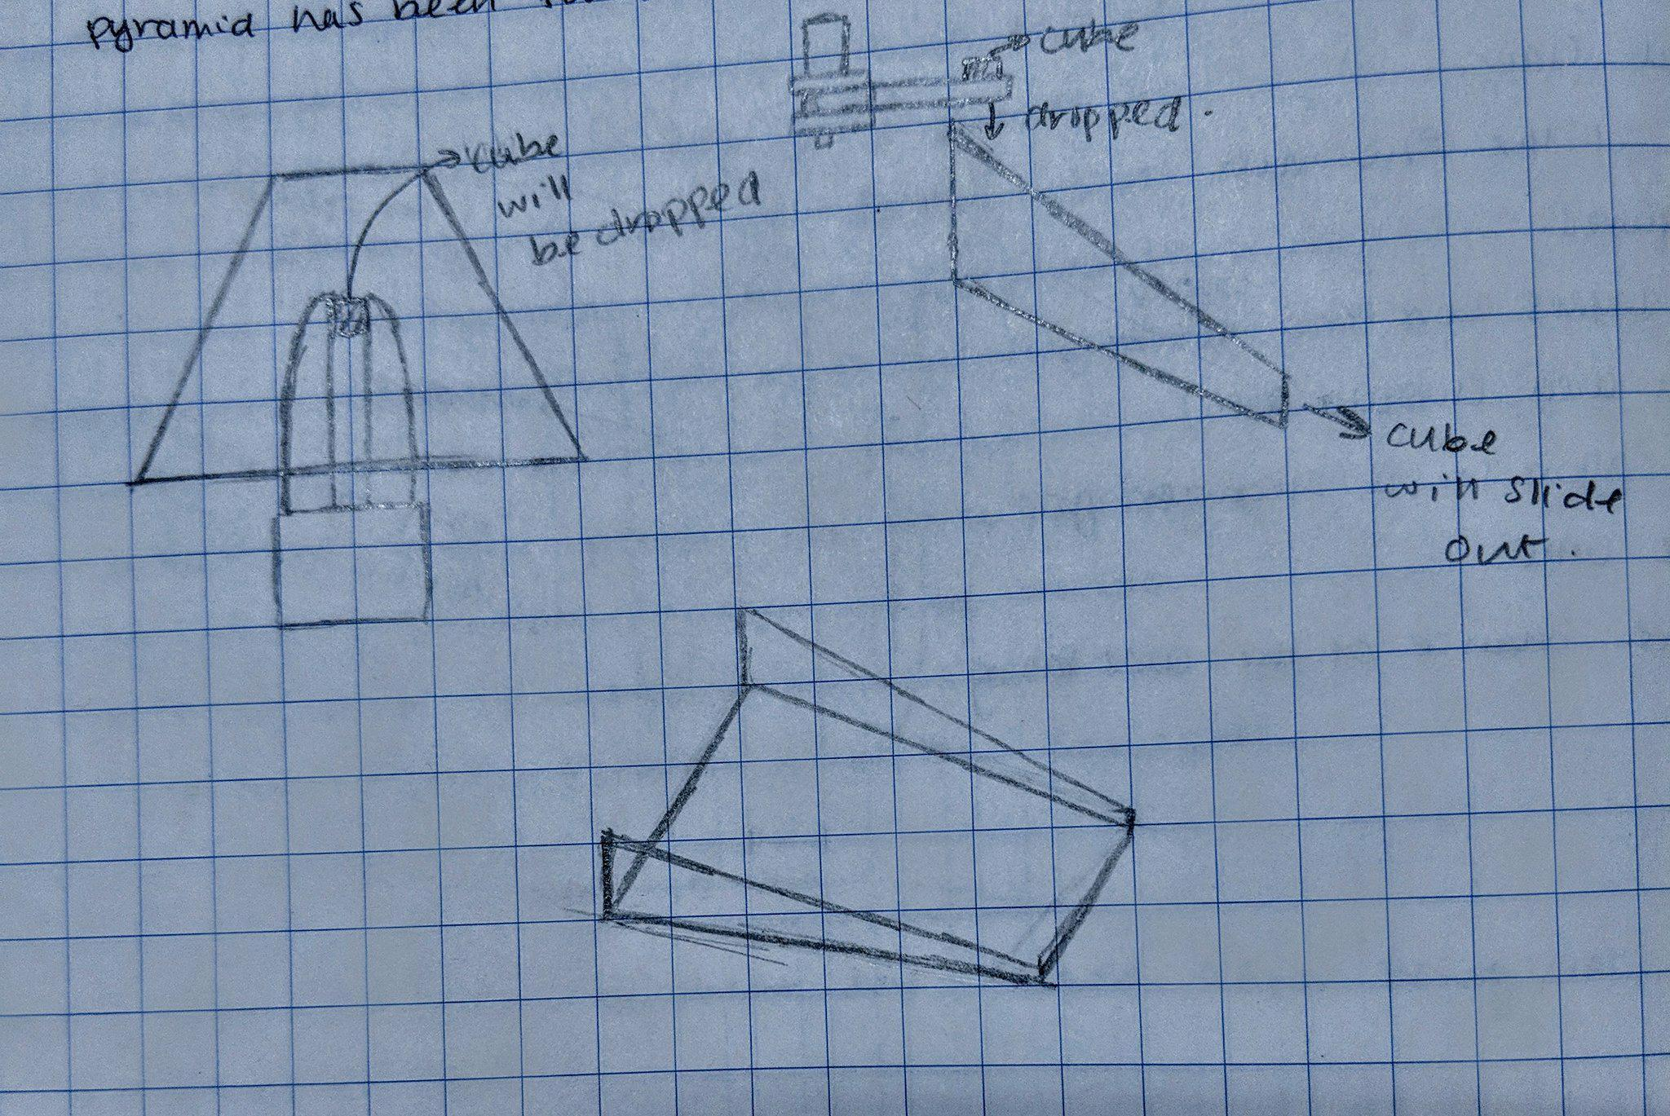

**Cube Location**

Since the tesseract contains a magnet, a hall effect sensor can be used to detect the magnetic field created by the tesseract. In addition, a magnetometer or a compass can be used to take advantage of the magnet inside the cube. Both of these sensors, however, could pickup magnetic fields from other ferrous parts of the robot and so it must be ensured that the cube manipulation mechanism is built as nonferrous as possible. As the magnetic intake mechanism would inherently be problematic, the intake could constantly be rotating along the wall, and when the cube is retrieved, a limit switch or ultrasonic range finder could detect possession.

**Note -** The concepts modeled below were modeled to provide a clear visual basis for the ideas presented. This ensured that all members fully understood each concept. The use of VEX parts allowed the group to complete these models quickly which resulted in more efficient concept generation sessions. The models below are not a representation of the final product.

**Drive Concepts**

**Chassis Heights**

**Low Chassis:** Pros: Easier to implement. Gives you more space to build. Cons: Would need more wheels and perhaps more than 2 motors. May not go over the conduits.

**High Chassis:** Pros: Can go over the conduits with ease. Will at most require four wheels although more are possible. Cons: Loses some build space. More materials are required to elevate chassis.

**Mecanum Drive Design Concept (CAD)**

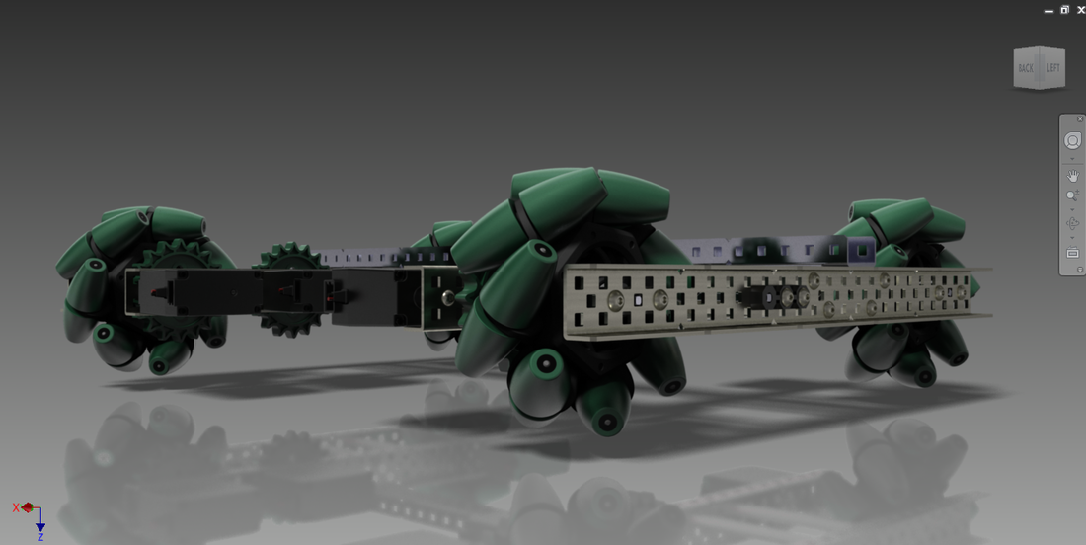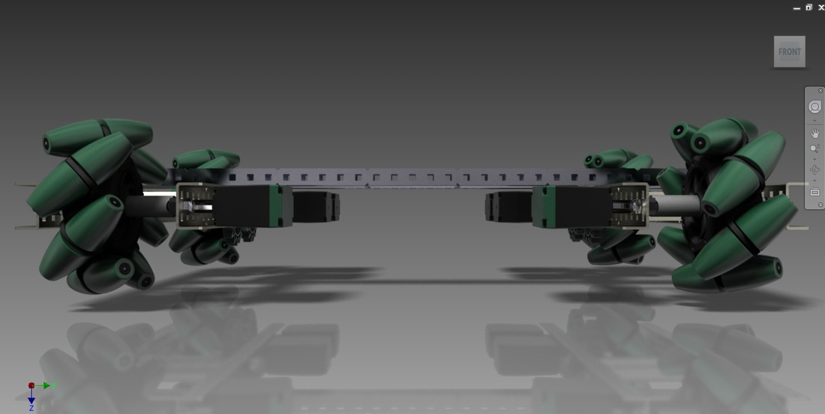

The four-wheel drive train proposed will be elevated >1 inch through the use of 4-inch wheels to be able to drive over the conduits in the power plant. A holonomic drive is preferred for the ability to drive in all directions without turning to best locate the cube,

and will be experimented with to support this decision.

**Tank Drive Design Concept (CAD)**

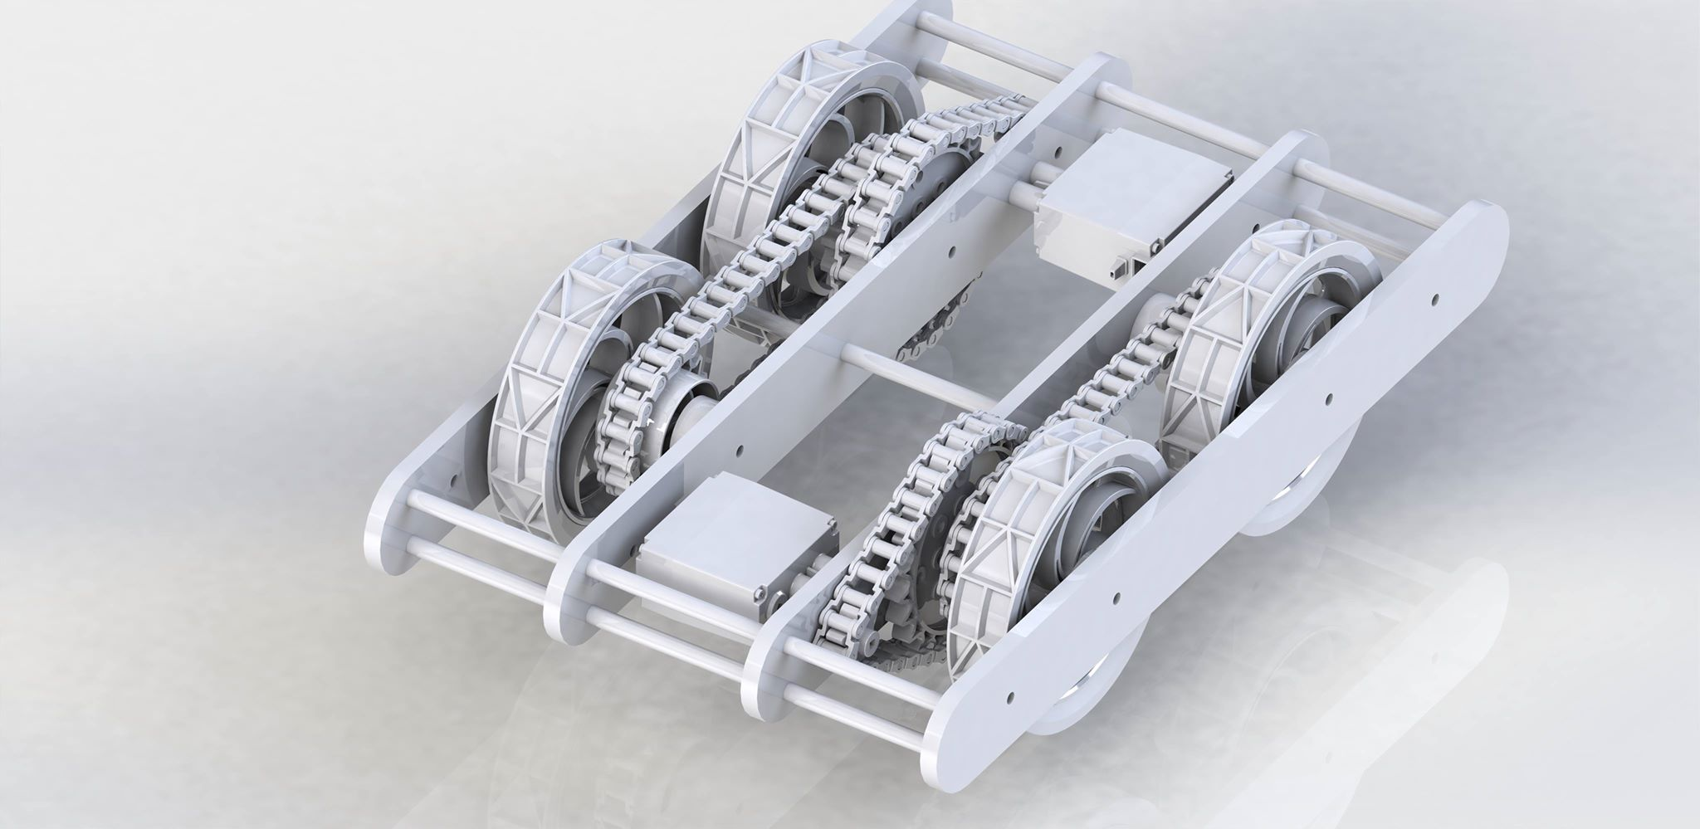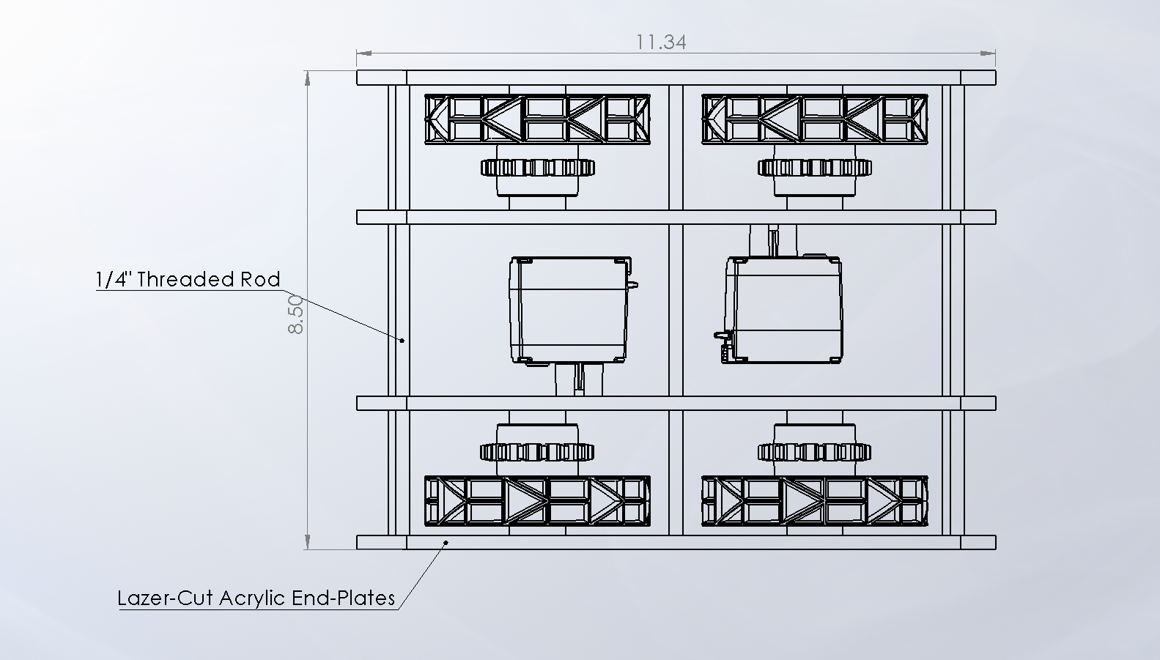

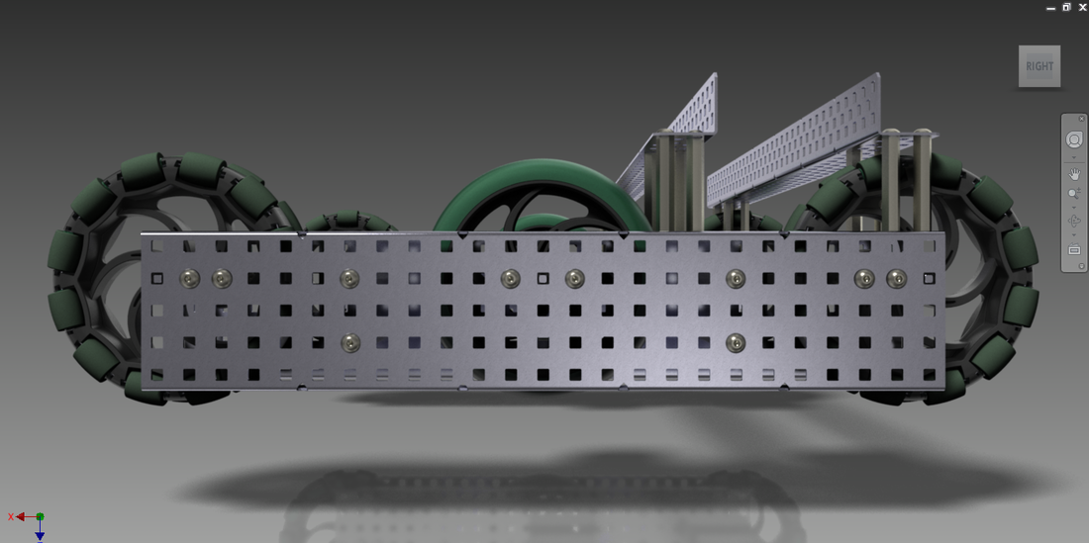

This chained tank drive allows the use of only two motors, with power distributed to both wheels on either side. This is a much simpler design that would make programming more reliable.

**X-Drive Holonomic**

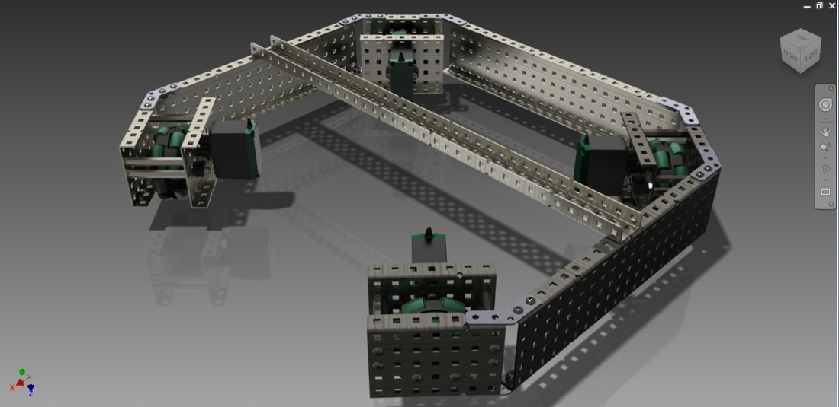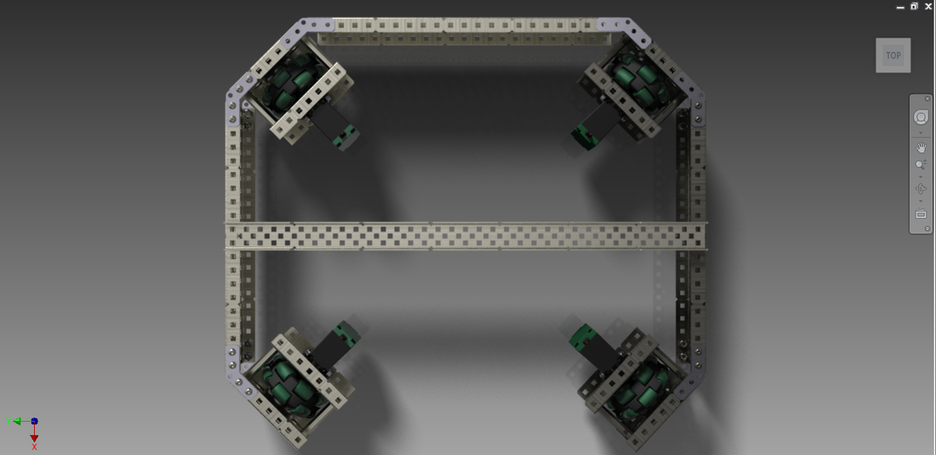

A 4 wheel 4 motor drive with wheels angled at 45 degrees allows for maneuvering forward and backwards, and left and right.

**H-Holonomic Drive**

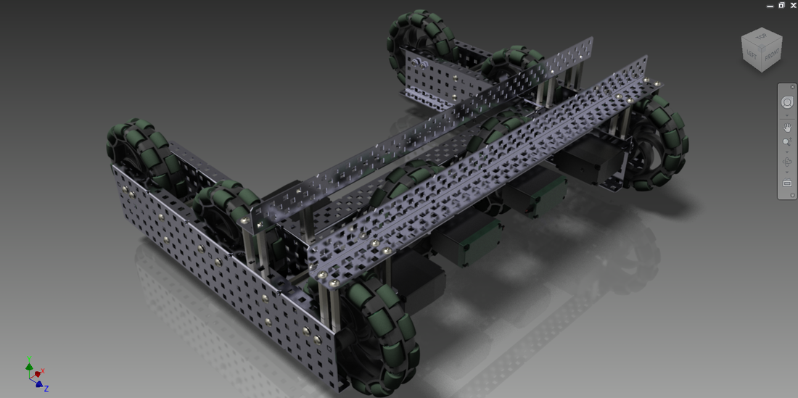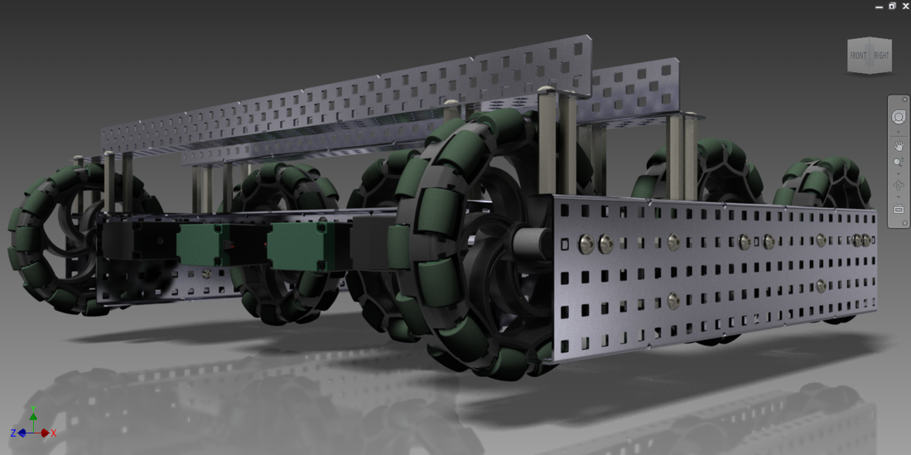

An additional motor powering a perpendicular wheel allows the robot to maneuver left and right. May compromise space.

**Lift Concepts**

**Lift Design Concept**: If a need for a lift is found, it is suggested the lift be a linear lift to best maneuver the tesseracts and Pyramids autonomously, or a simple non-linear lift design for reliability.

**Simple Lift**

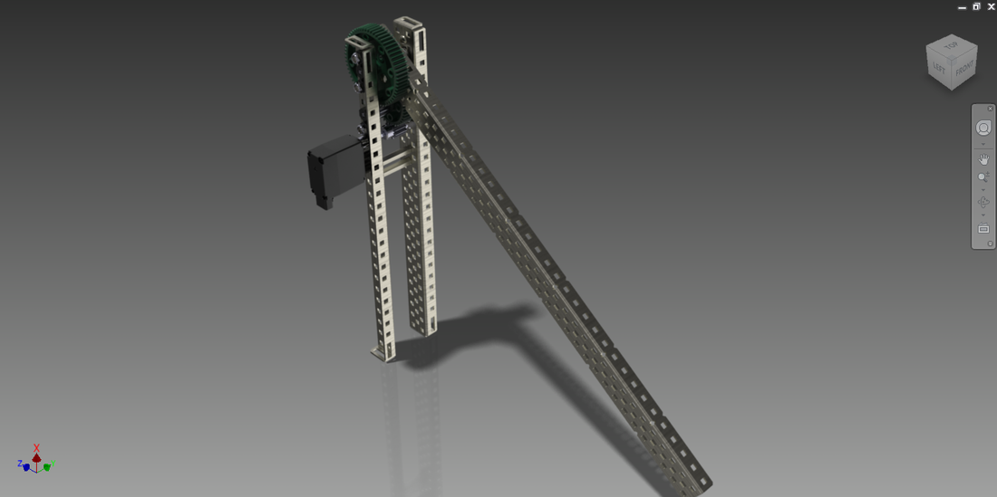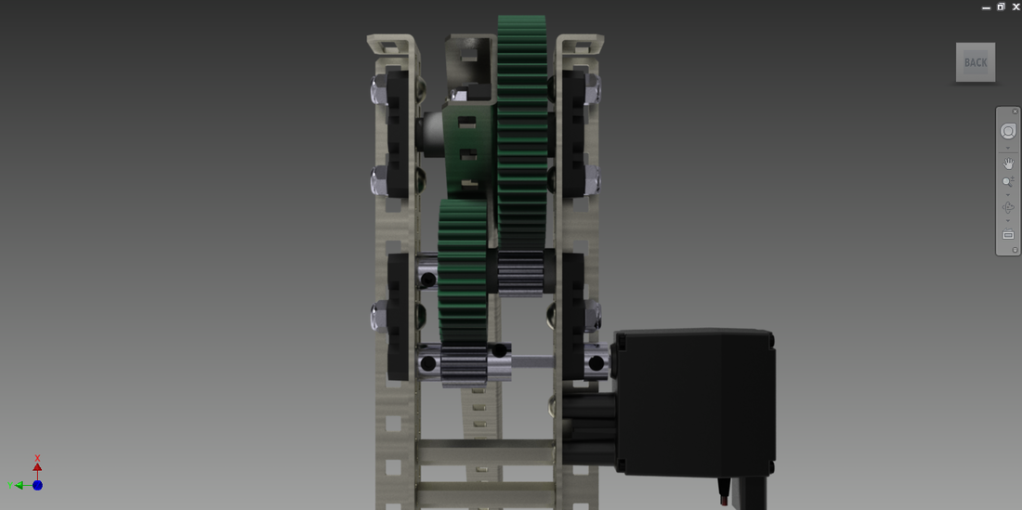

**Chain Bar**

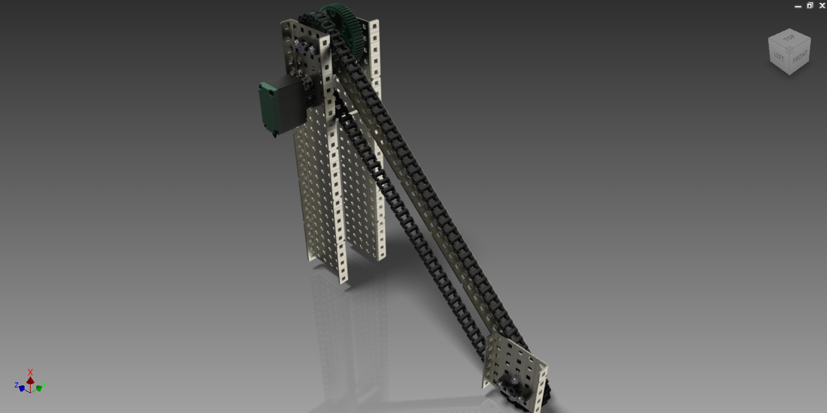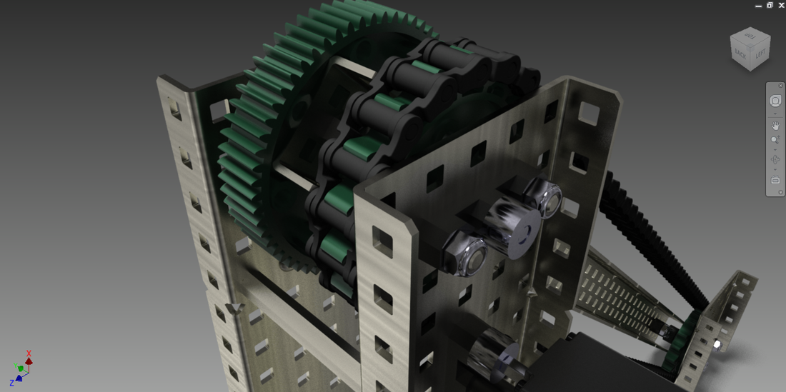

**4-Bar Linkage**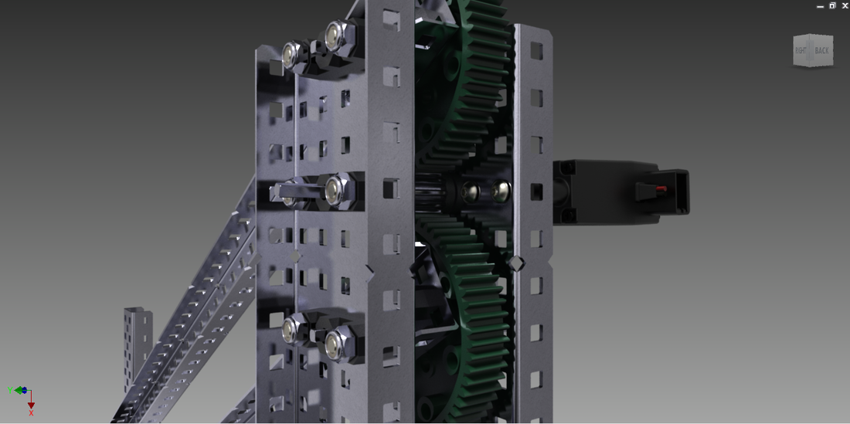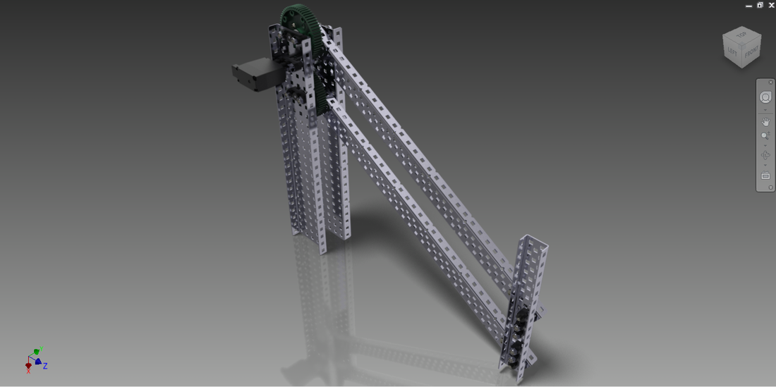

**Concept Evaluation**

After concepts were fully discussed and defined, they were objectively compared through decision matrices to select the best concept. Some design decisions were made during discussion or selected based on other concept selections.

**Cube Manipulation**

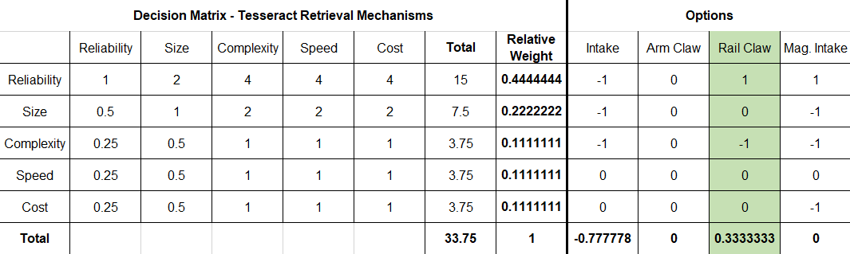

Out of the three designs, it was decided through a decision matrix that the rail claw would be best for cube manipulation due to its ability to reliably retrieve the cube at large heights and lengths from the robot and bring it to a position underneath the robot. The Arm claw would require the cube to drop into an indeterminable position and the magnetic intake would result in a lack of sensor data, although possibly a quicker method.

**Cube Storage and Release**

The claw’s servo closed position will be set greater than perpendicular to the cube and along with the use of a gripping material, the claw will be able to securely store the cube. A ramp at the center of the robot was chosen to best support the rail claw, which would utilize a rack and pinion rail to bring the claw and cube into the center and drop it through the funnel created by the ramp.

**Cube Location**

Since the cube retrieval mechanism will not use any magnets, a magnetometer will be used to detect the location of the cube. A compass magnetometer has the ability to detect magnetic fields in all three directions (x, y, z) which will give a much more accurate reading than a hall effect sensor, which only provides a reading within inches to the magnet, after initial tests.

***Tesseract Sensor Tests***

|  |  |  |  |  |  |
| --- | --- | --- | --- | --- | --- |
| **Distance Detected (cm)** | 10 | 5 | 3 | 2 | 1 |
| Magnetometer | No | Yes | Yes | Yes | Yes |
| Hall Effect | No | No | No | Yes | Yes |

**Pyramid Manipulation**

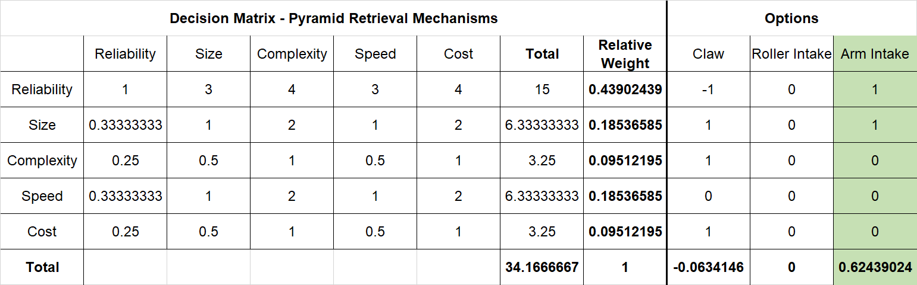

The decision matrix resulted in the Arm Intake to be selected. The Arm Intake has a reliable method of containing and releasing the pyramid with a large normal force. The claw may face issues with spontaneously dropping the pyramid if the suction cups were not strong enough and the roller intake’s large nature would be unpredictable and would most likely require a wall to push up against.

**Pyramid Storage**

The pyramid would be stored in a forklift type ramp which has an indented cutout at the bottom to allow for the cube to be placed underneath the pyramid. When this is done, both the pyramid and cube could be released onto the field, with the challenge completed.

**Pyramid Location**

It was decided to use the IR sensor to detect the pyramid as determining which pyramid was the correct one is essential.

**Drive Design**

While several drive designs were developed, after the initial status report meeting, it was determined that holonomic drives would lead to several problems during the autonomous run, including the robot moving left and right without a good way of detecting this motion. As such, the tank drive using 4-inch wheels was selected, as this would be high enough to move across conduits, and be a reliable drive to program. Two distance sensors on the side of the robot will be used to follow the wall at a distance to search for the cube, while a distance sensor at the front will be used to detect when a turn is to be made.

**Lift Design**

As the Arm Intake mechanism was pursued, a lift is required to elevate the pyramid above the cube and maneuver over the conduits without the intake hitting them. A horizontal four-bar design was selected due to its strength torque versatility.

**Electronic Design**

While the MSE-Duino provides functionality due to the two microcontrollers, other ARM and AVR based microcontrollers were also considered for higher speed of sensor computation and more I/O.

|  |  |  |  |  |  |  |
| --- | --- | --- | --- | --- | --- | --- |
|  | STM32-F429ZI | STM32-F446RE | MSE-Duino | Arduino Mega |  |  |
| Test: | ARM  Cortex-M4  @ 180MHz | ARM  Cortex-M4  @ 180MHz | AVR ATmega328p  @ 16MHz | AVR  ATmega2560  @ 8MHz |  | Arm Improvement over AVR |
| INT_LOOP(30000) | 19.95 | 19.95 | 3.98 |  | MIPS | **501.26%** |
| LONG_LOOP(30000) | 19.99 | 19.99 | 2.24 |  | MIPS | **892.41%** |
| FLOAT_DIV(30000) | 2.22 | 2.22 | 0.21 |  | MFLOPS | **1057.14%** |
| DOUBLE_DIV(30000) | 2.05 | 2.05 | 0.21 |  | MFLOPS | **976.19%** |
| FLOAT_MUL(30000) | 1.63 | 1.63 | 0.21 |  | MFLOPS | **776.19%** |
| DOUBLE_MUL(30000) | 1.51 | 1.51 | 0.21 |  | MFLOPS | **719.05%** |
| CoreMark |  | 602.44 |  | 4.25 | Points | **14175.06%** |
| Calculate PI as fast as possible | 5000 | 5000 | 63000 | 80000 | milliseconds | **1260.00%** |
|  |  |  |  |  |  |  |
|  |  |  |  |  |  |  |
| Specs: |  |  |  |  |  |  |
| Architecture | 32-bit ARM | 32-bit ARM | 8-bit AVR | 8-bit AVR |  |  |
| CPU Freq | 180 | 180 | 16 | 8 | MHz |  |
| RAM | 256 | 128 | 2 | 8 | KB |  |
| FLASH | 2048 | 512 | 32 | 256 | KB |  |
| I/O Pins | 144 | 64 | 28 | 64 | Pins |  |
| UART / USART Buses | 8 | 6 | 1 | 4 | Buses |  |
| I2C Buses | 3 | 3 | 1 | 1 | Buses |  |
| SPI Buses | 6 | 4 | 2 | 5 | Buses |  |
| ADC | 12-bit, 24-ch | 12-bit, 24-ch | 10-bit | 10-bit | Bits |  |
| Interrupts | All GPIO | All GPIO | 2 | ? |  |  |

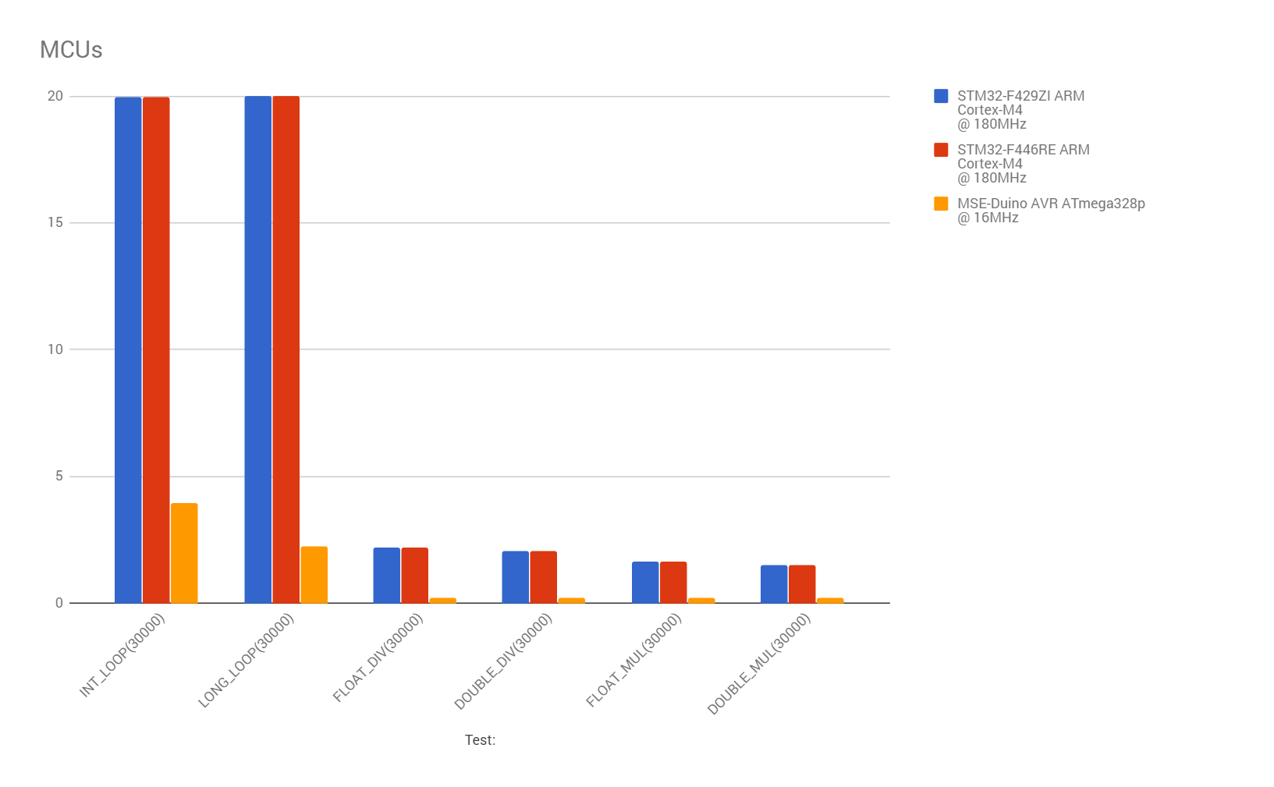

**Product Design**

**Project Generation**

**Meeting Minutes #4**

**Date: March 9, 2018**

**Agenda:**

* Select the materials to be used in the product
* Decide on methods to replicate the product as closely as possible using the materials available for the product

**Discussion:**

1. **Material Selection**

* The materials used on the product should be non-ferrous
  + - The tesseract has a magnet inside so it would stick to magnetic materials
    - This can disturb the process
      * If the cube sticks to a part of the robot the cube might not be able to be retrieved and placed under the pyramid correctly
    - Aluminum, carbon fibre, Lexand, acrylic and wood are some non-ferrous options
      * Aluminium components can be used for portions of the robot that are under a lot of loading and need to be relatively strong and non-brittle

Much lighter than steel and nonferrous

* + - * Acrylic is a good material to use for parts of the robot that are not under much loading

Acrylic can be laser cut easily so manufacturing different parts from it is very simple.

Light weight

Acrylic is brittle so it cannot be bent into different shapes

Glue with small connectors (also cut from acrylic) could be used to make 3 dimensional designs from the laser cut piece

**Concerns –** since acrylic is brittle the parts made from it would be easily damaged if they fall or are loaded in a non-favorable angle.Gluing the pieces will also result in mechanisms with low structural integrity as glue might not hold the pieces together securely enough

* + - * Lexand components would be stronger that those made out of acrylic and they can be bent to make the 3-dimensional mechanisms on the product.

Although they cannot be laser cut, they can be machined using plastic specific tools and machines.

Lexand is a good alternative for the cube and pyramid retrieval mechanisms.

1. **Prototype Design**

* The 4 inch VEX wheels available in the lab will be used on prototype instead of the 5” elastic wheels selected for the product.
  + These wheels are harder that the wheels selected for the product so they may have some traction problems when going over the conduits
    - Extra grip might need to be added to make the drive base more closely replicate the product
* VEX 393 motors with integrated encoders are used instead of the Nemo 23 motors selected for the drive base.
  + These motors are not as strong as the motors selected for the product and have different internal gearing so they will have to be geared differently
* Use laser cut acrylic pieces for the cube pick up and the pyramid intake
  + Must note that this will be less durable than the actual mechanisms since acrylic is more brittle than Lexan and aluminium.

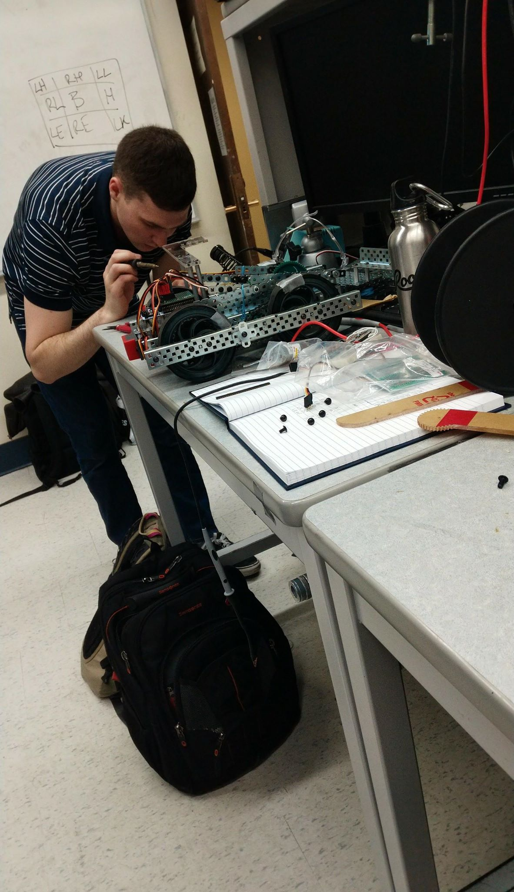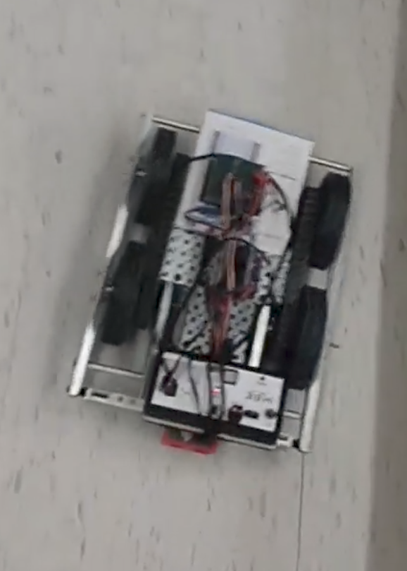

**To be completed:**

1. Complete the CAD for the intake and cube pick up parts that need to be laser cut for the prototype
2. Complete the prototype
3. Finalize the Product materials and designs.

**Cube Manipulation and Storage**

**Product**

While the initial design was able to manipulate the tesseract promisingly, it would need to drop the cube from a high distance, resulting in bounce and roll. This would mean the robot would need to search for the cube again. As such, the rail design concept that was selected was pursued, that stores the cube within the claw, and when the pyramid is retrieved, drops the cube through the ramp (see Figure X for ramp).

In the final product all the parts for the rail design would be made out of ⅛ inch aluminum to ensure that the parts are non ferrous but durable and strong. The claws would be made out of acrylic since they are not under any great amount of loading. If manufacturing processes allow the claws could be made from 1 layer of ⅜ inch acrylic each (See Figure X for final cube retrieval design), If testing proves ⅜ inch acrylic to be to brittle aluminium can be used instead . The ramp is also not under a great amount of loading however it does have corners that need to be bent upwards. Instead of using 3 pieces of acrylic and gluing them to one another a piece of ⅛ inch aluminum can be cut and bent to form the ramp.

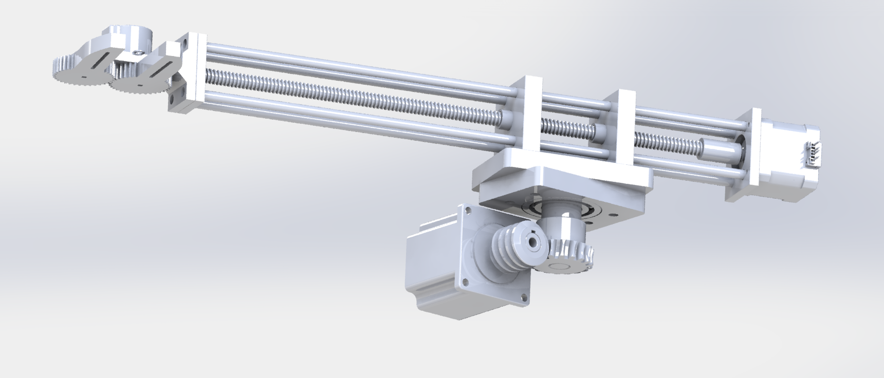

**Prototype**

Initially, an arm claw prototype was built with VEX parts to refine the claw concept.

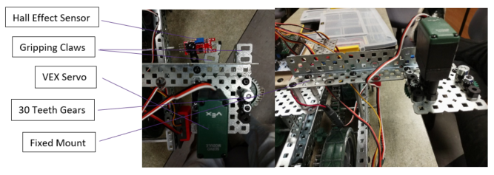

The claw prototype served as a proof-of-concept for the claw to be a feasible solution for the product, and allowed us to pursue this design. The VEX parts, however, are ferrous and our custom solution was pursued.

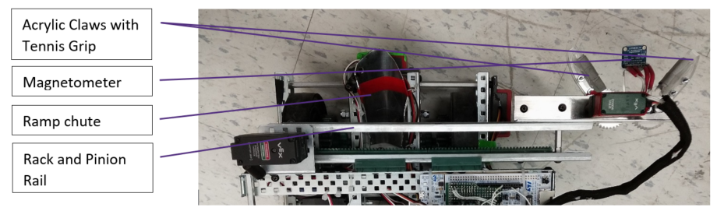

**Cube Location**

The **XX** magnetometer that was selected provided better results than the hall effect sensor in the product. It was also used to prototype the programming logic to locate the tesseract. However, it was noticed that it still would only locate the cube within 5 cm. This meant the the cube could not be located by the robot just turning and scanning the field from one location.

To ensure that the cube was retrieved every time, The robot would have to find a wall and track the wall as the magnetometer scans the top of the wall for the cube. This process would take longer than a randomized search in some cases but it is more consistent which is our most most important design requirement. The magnetometer will be mounted directly above the claws of the cube retrieval mechanism to ensure that the cube is located just as the claws are approaching it.

**Pyramid Manipulation / Storage and Elevation**

**Product**

The final product will consist of 2 motors, running in the opposite direction at all times.The motors will be inwards when the pyramid is being retrieved and running outwards after the pyramid is placed on top of the cube. The motors and wheels connected to them will be at the same angle as the pyramid to ensure that maximum contact surface area occurs the wheels and the pyramid.

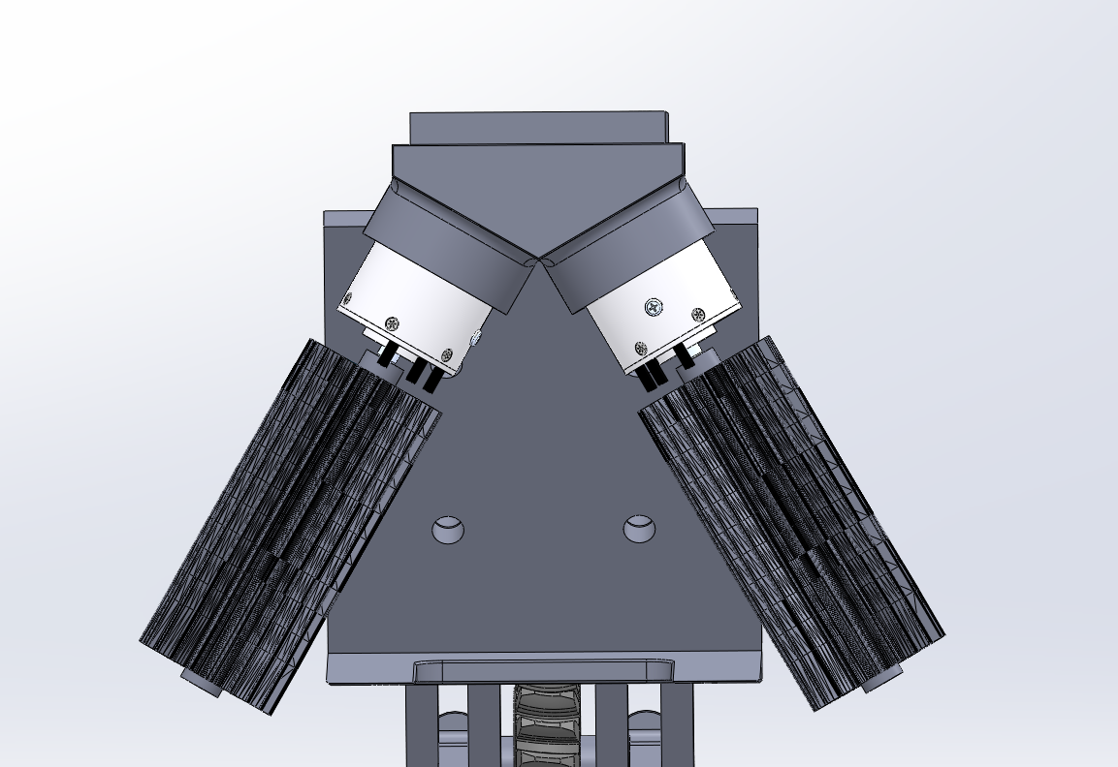

Tests conducted using various prototypes showed that a 10 degree incline for the bottom of the forklift is the most effective angle for intaking the pyramid. These test were conducted by putting the intake at 7 different angles and 10 trials were conducted per angle. As the result the intake is placed at a 10 degree incline.

The bottom of the forklift must be less than 1/32 in thick at the tip to ensure that the bottom of the pyramid does not get caught on it. 1.32 in thick carbon fibre will be used for this bottom piece. Carbon fibre is durable and despite being very thin in this case it will not break easily.

The carbon fibre will be connected to an aluminium piece at the bottom if this piece is too flexible to ensure that the pyramid would not slide off of the intake when being pulled up. The aluminum piece would only be half of the size of the bottom piece to ensure that the tip of the piece is thin enough.

The entire intake system will be lifted to lift the pyramid after the pyramid is retrieved. This is done through the use of a arm with 2 joints attached to a motor. The motors used will be discussed under the engineering analysis section. This arm will lift the pyramid and the intake so that the pyramid can be placed over the cube. This lift system will also keep the intake up when navigating the field to ensure that the intake does not get caught on the conduits.

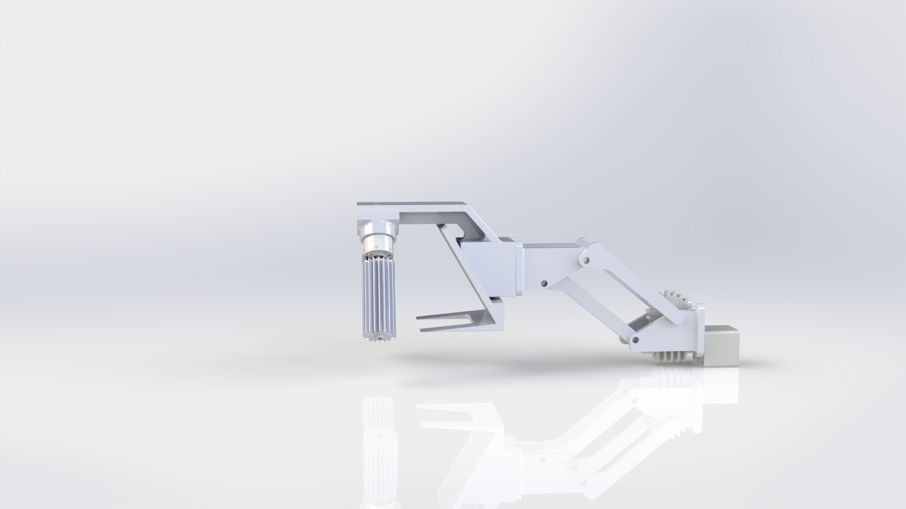

**Prototype**

The roller design was prototyped with VEX parts. Different gripping mechanisms were tested that included VEX intake wheels and LEGO wheels.

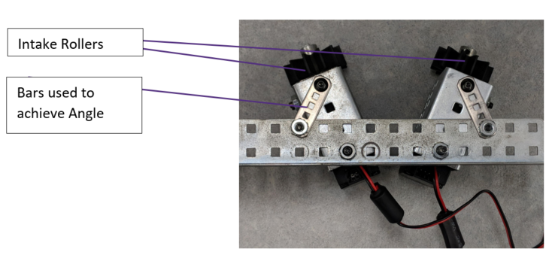

Testing this prototype allowed us to understand that the ramp needed to be thinner than 1/16in in order to reliably push the pyramid up the ramp. In addition, doubling the intake wheels on each side was found to be a better solution as it increased the contact surface area.

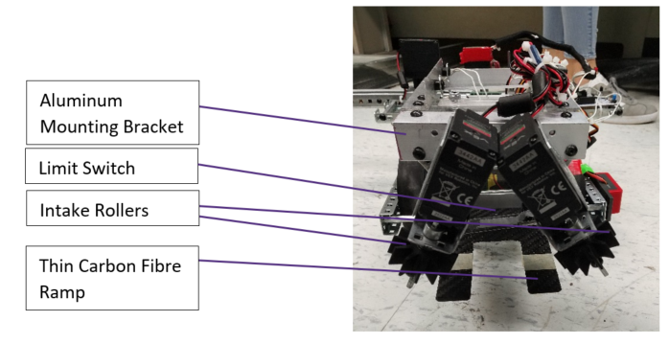

The selected design allows the pyramid to remain on top of the ramp, held in by the rollers. However, the carbon fibre sheet was not strong enough to hold the pyramid on its own when elevated, and so, 1/16in aluminum was mounted halfway underneath the carbon fibre sheet to maintain rigidity. The Aluminum piece mounted also allowed us to give the tip of the carbon fibre a downward angle which eased the intaking processes as the pyramid would not get caught on the tip of the bottom of the forklift.

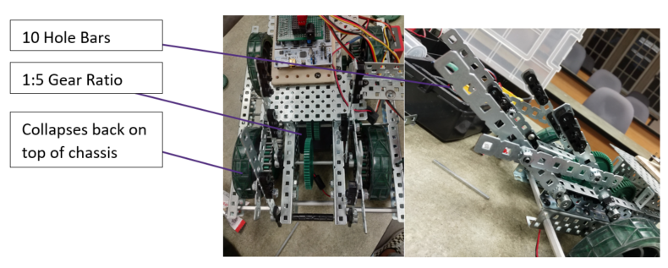

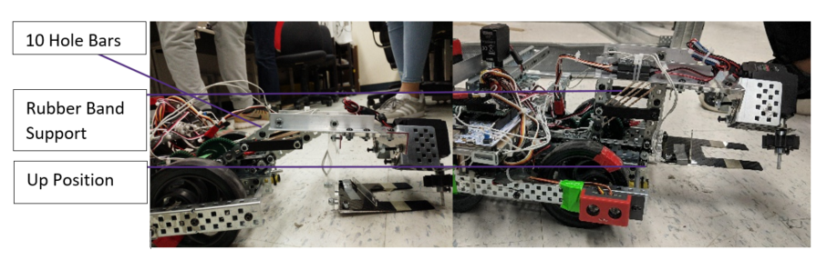

**Pyramid Location**

The IR sensors being used have at most a 28 inch range, undervaluing this range just to be safe would give results in a maximum range of approximately 2 ft for the wide (unshielded) IR sensor on the robot. This range is too small for the robot to be able to rotate at one pint of the course and pick up the signals from the two pyramids.

Using pythagorean theorem we see that if the robot is exactly in the middle of the field there is a distance of 4.24 ft to 7.07 ft between the orbot and the farthest corner of the field for a field ranging from 6ft to 10ft respectively.

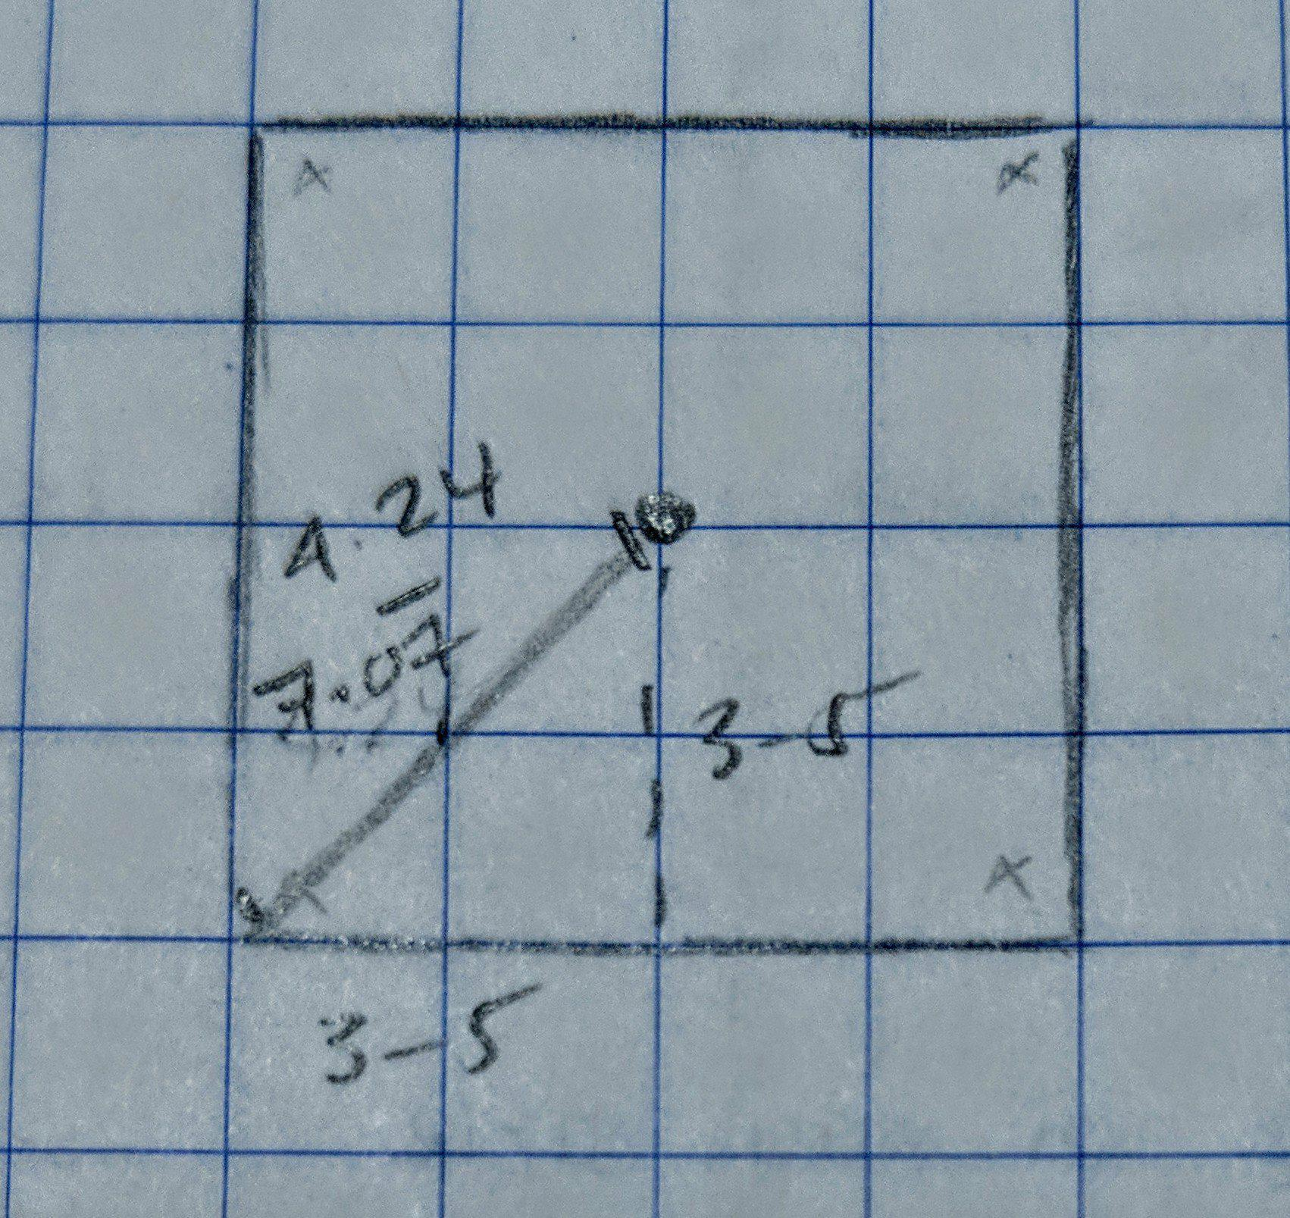

Assuming the robot is at one corner of the field the largest distance increases to a range between 8.49 ft to 14.14 ft.

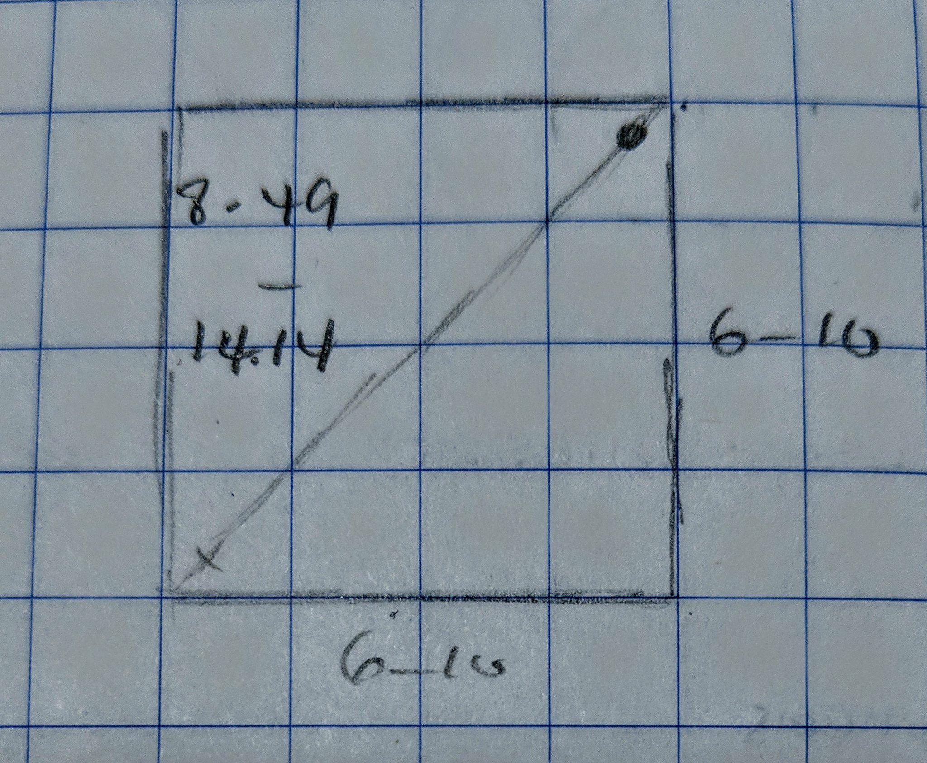

Since the distance between the pyramid and the robot can be more than 2 ft the robot must navigate through a path and search for the pyramid. This robot must rotate and scan the field every 4 ft. Although a systematic path being taken might not always be the fastest depending on where the pyramids are located, a systematic approach allows us to always, eventually locate the pyramid. A randomized approach might result in the pyramid being missed. The systematic path drawn below is suggested as the path to be taken.

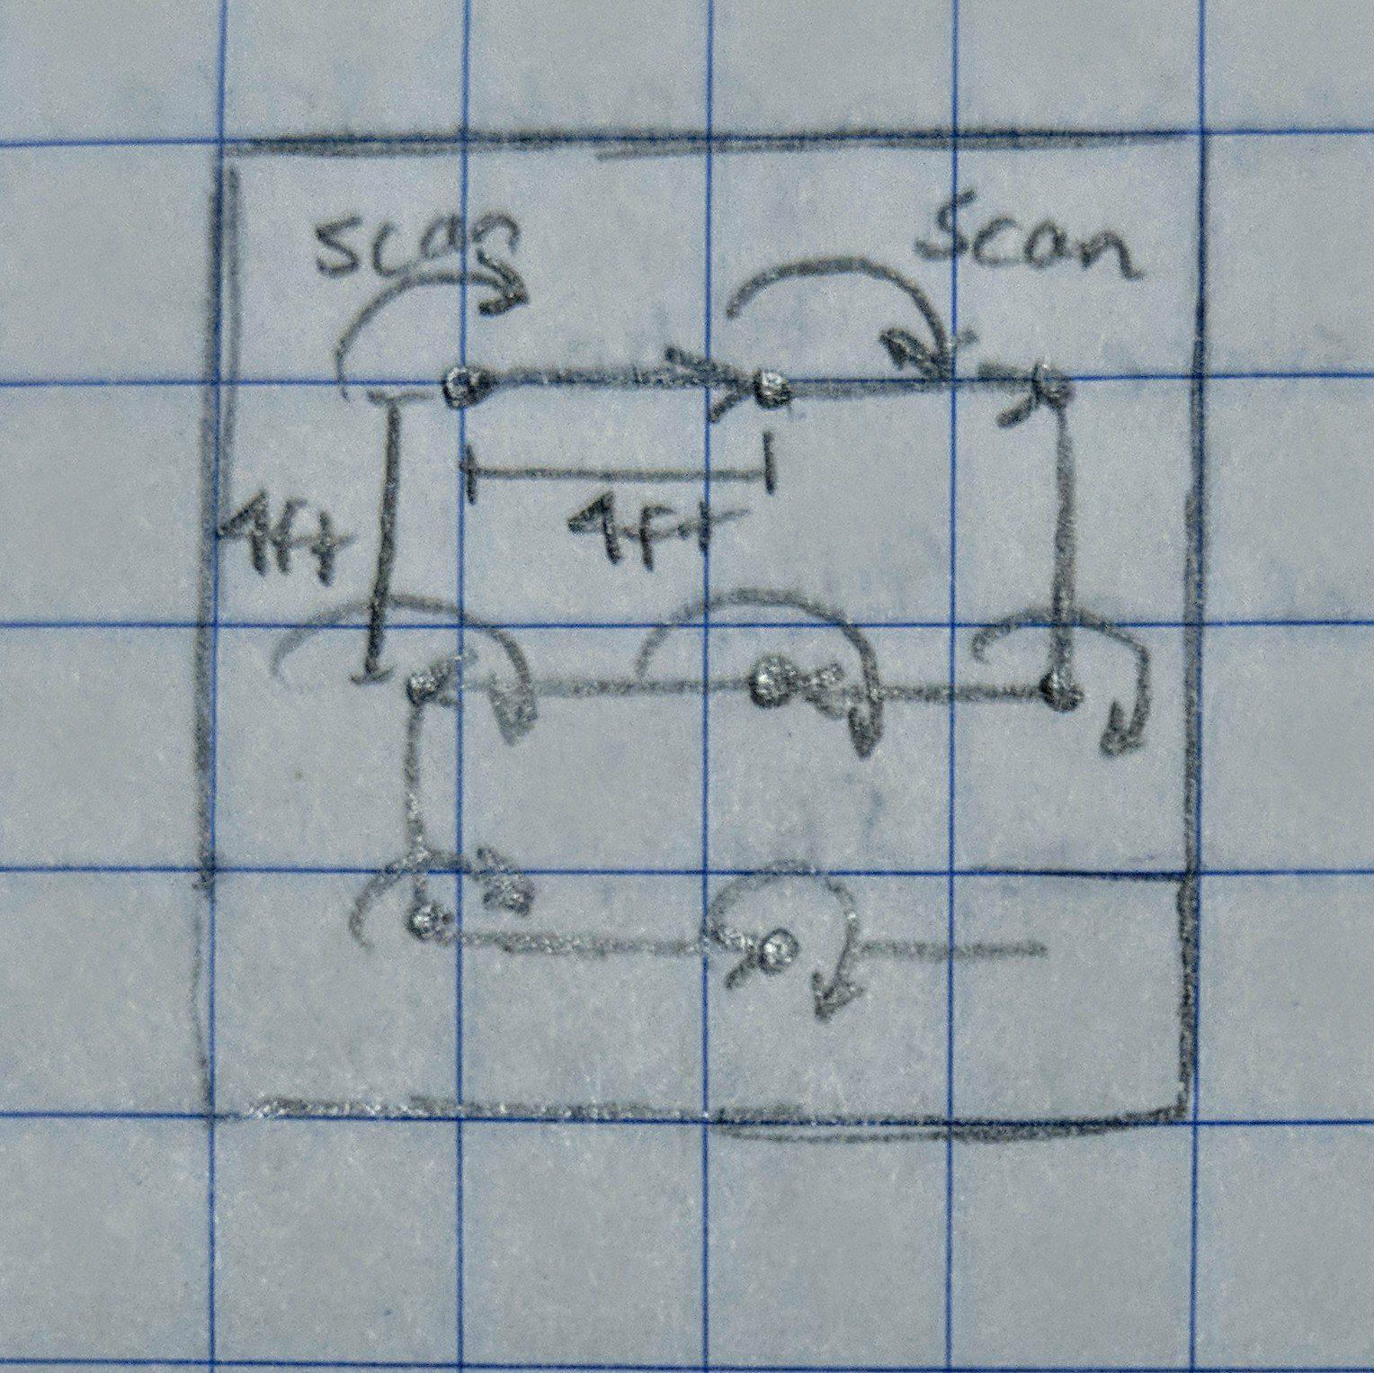

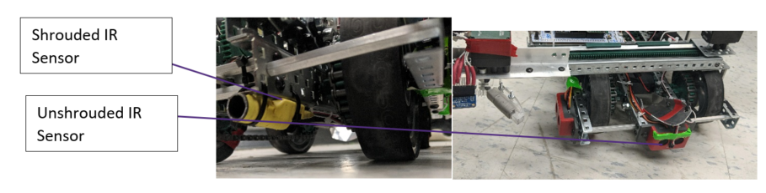

**Drive Design**

**Product**

The base of the robot will be built out of aluminium to ensure that it is strong, light and non-ferrous. 4” elastic wheels from McMaster-Carr are being used as the 4 wheels of the robot. These wheels are very soft and have very good traction so they would not slip over the conduits. The two wheels on each side will be controlled by 1 motor. chain wil be used to connect the two motors. The length of the chain be modified in the wheels need to be farther apart or closer to one another.

Finally the 4 wheel design offers stability for the robot as it navigates over conduits resulting in a smooth navigation.

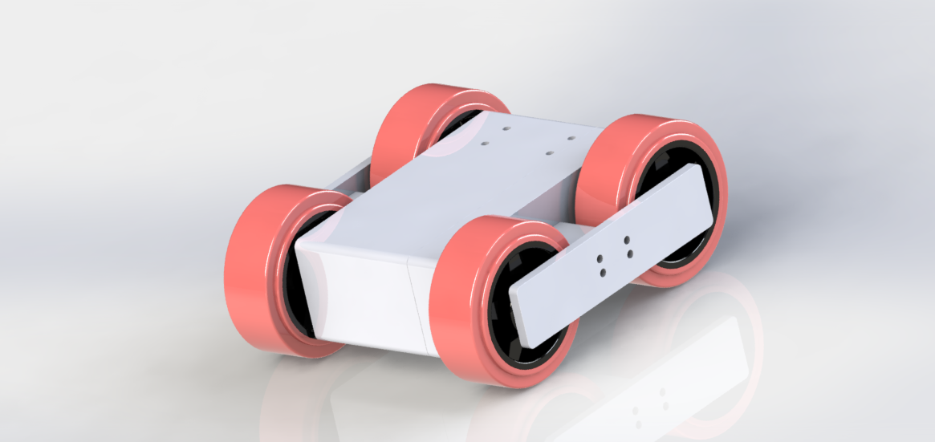

**Prototype**

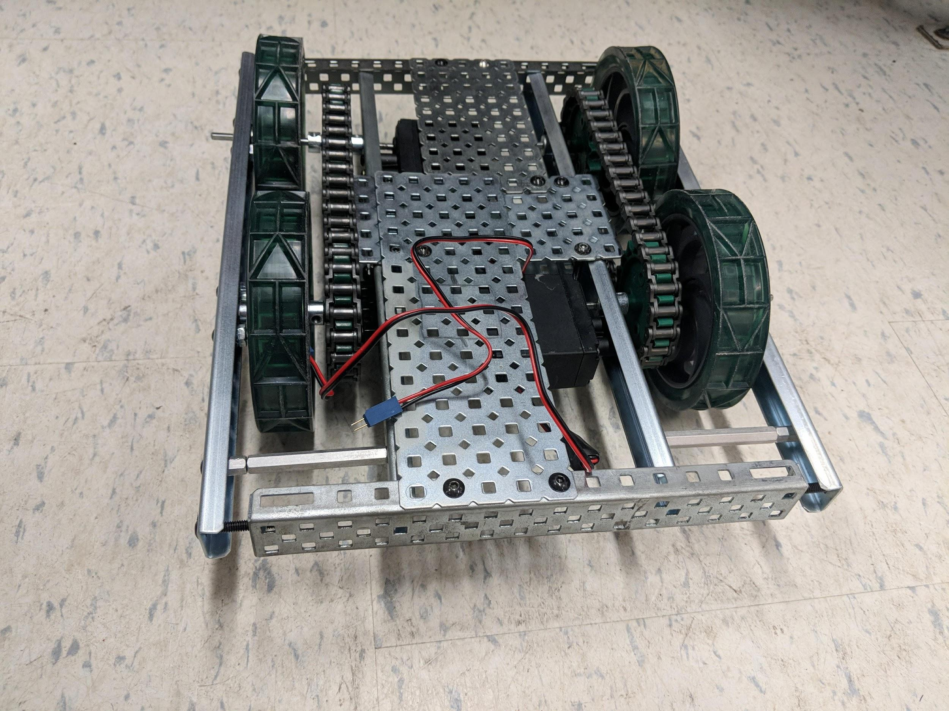

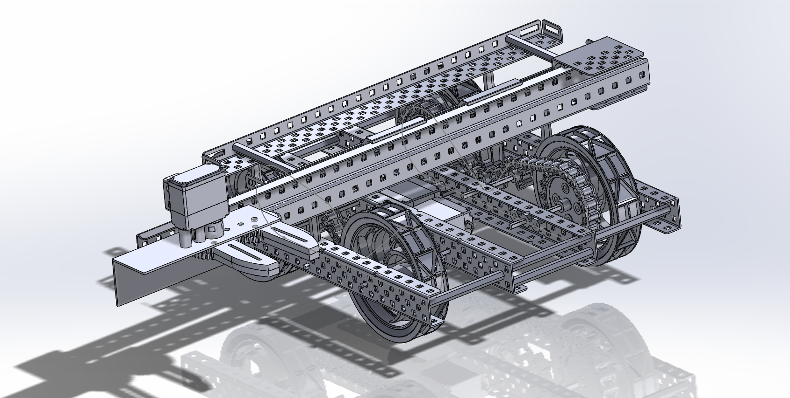

The prototype was built using the materials available in the lab. 4” VEX wheels were used. The wheels were quite hard and as the result they slipped over the conduits. Tennis racket grips were added to the wheels to increase their traction so they could replicate the product more closely. VEX 393 motors were used instead of the motors selected for the product. Since these motors were weaker than those on the product additional gearing was required to replicate the product. This addition made the prototype larger than the actual product.

**Full Product Design**

As a whole, the Tesseract Robot has the ability to locate, retrieve and store both the tesseract and the pyramid. The rail claw provides degrees of freedom in both X and Y, and has a reliable nonferrous claw system to grip the tesseract. The pyramid intake with two large rollers are designed in the shape of the pyramid to maneuver it with ease. It is coupled with a strong 4-bar lift system to elevate the pyramid to finally place it above the tesseract. The Tesseract Robot is designed with a powerful drive system that is able to conveniently drive its low weight of 6.7kg.

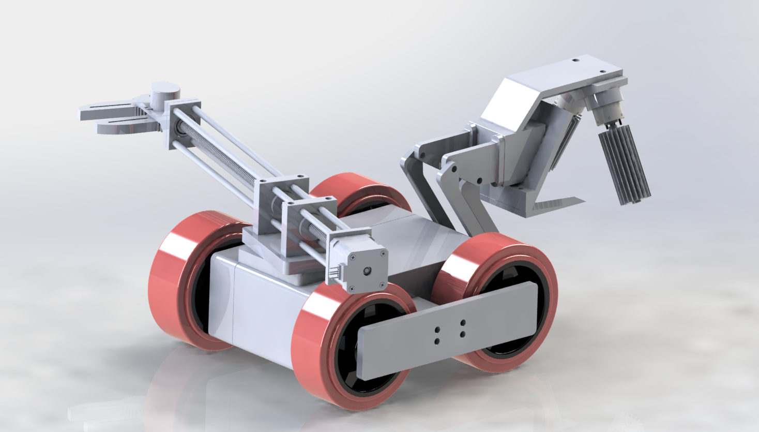

**Full Prototype Design**

The prototype was developed with the product as a model with VEX, laser cut acrylic, aluminum, and carbon fibre parts.

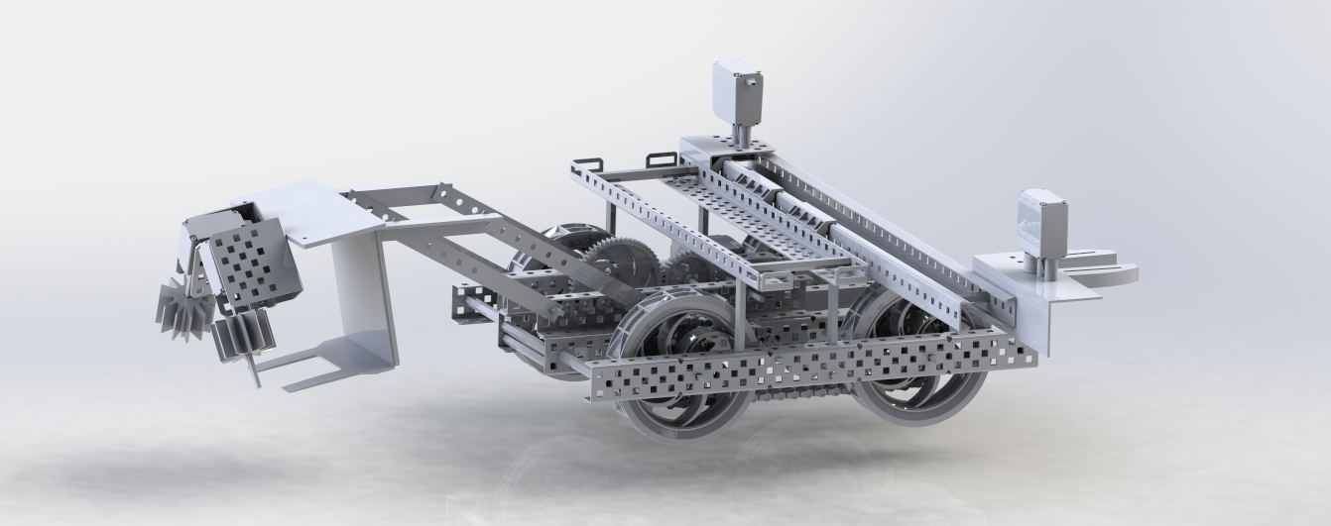

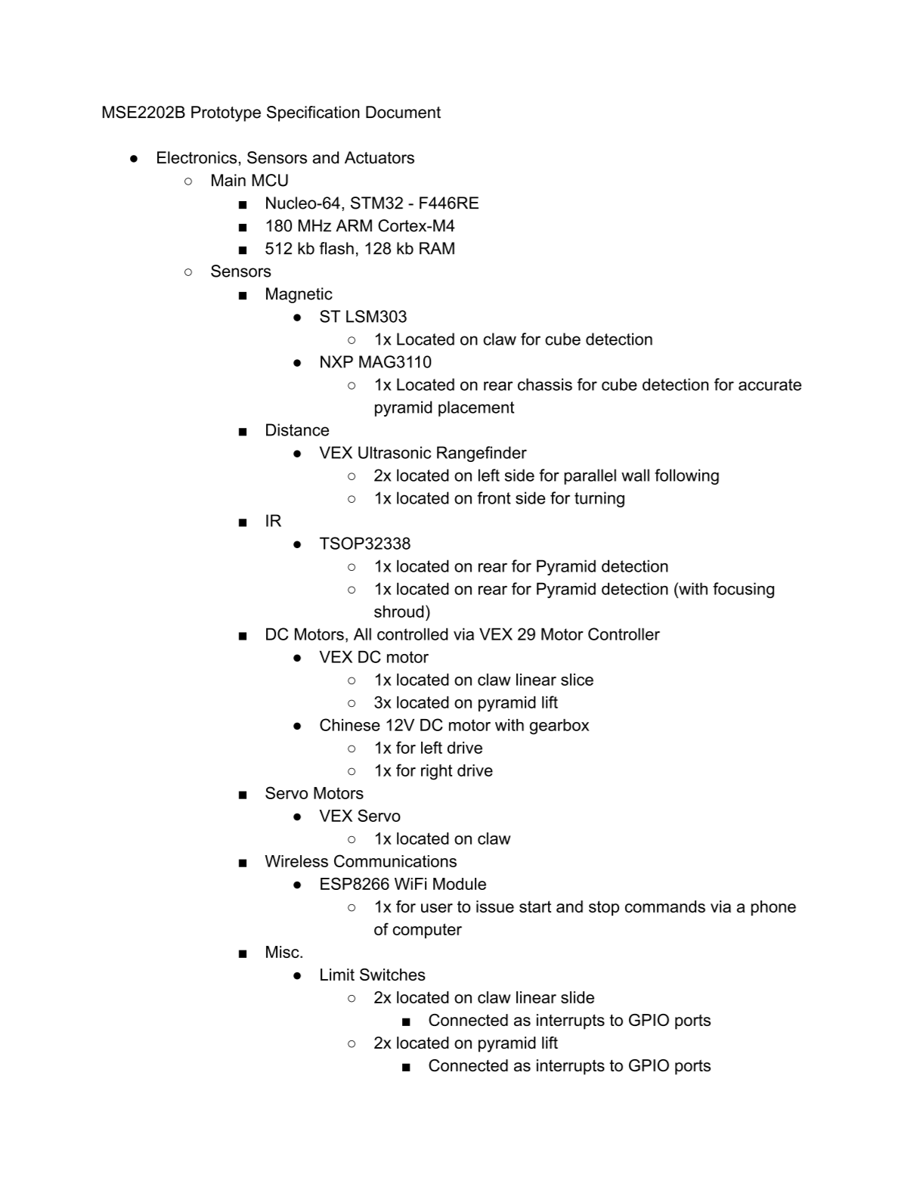

**Electronic Design**

**Discussion**

A third party microcontroller was usedh due to increased I/O and computational capabilities when compared to an ATmega238p. STMicroelectronics Nucleo development boards were selected for use on the prototype. Nucleo development boards are an Arduino alternative with superriour capabilities when compared to AVR microcontrollers. Two appropriate boards were obtained for this project: a Nucleo-144 with an STM32-F429ZI MCU, and a Nucleo-64 with an STM32-F446RE MCU. STM32 is a line of industrial grade ARM Cortex-M based microcontrollers offered by STMicroelectronics. A summary of the specifications and a STM32 block diagram for these boards is listed below in Figure 1.

The main benefits for using this alternative microcontroller include:

* greater number of GPIO ports
* greater number of IRQ ports
* greater computational capabilities
* easier interfacing with I2C peripherals (does not require logic level shifter)
* multiple hardware UART buses
* theoretical higher polling rate for sensors

A Pinmux is provided below in Figure 2 for the Nucleo-64 which outlines how every peripheral is connected to the STM32 controller. Two Block Diagrams of the electronic components are listed below. Figure 3A is the initial planned peripheral layout. Figure 3B is the peripheral layout which was used on the prototype.

A Daughter board was developed to provide easy VEX plug-and-play capability to the Nucleo Controller Boards. See the schematic below. The pins on the final revision are separated into low and high power tolerances. High power pins provide a GPIO pin with pwm capability for motors. These High power pins are routed through a voltage regulator which provides high current directly from the battery. The low power pins provide GPIO communications for various basic sensors and interrupts. 5V is provided from the host board. Additional pins included UART 7, UART 8, and I2C1 for various peripherals. All pins and sockets are 0.1” pitch which complies with the Arduino UNO header standard, and the VEX sensor connectors.

A Three-axis magnetometer was solely used to detect the tesseract while on the wall. This sensor interfaces with the controller through an I2C bus. The firmware required to interface with this sensor sends initialization, resolution, and read commands over the I2C1 bus to the sensor, then listens on the bus for the response. Three 16-bit values are returned from the sensor; one for each axis. The the software simply calculates the Euler magnitude of the magnetic field via the three readings. If this magnitude is greater than a threshold, then the robot will intake the tesseract.

The two infrared sensors are connected to hardware UART buses. This allows the STM32 to receive UART Rx interrupts to identify pyramids, however due to a lack of software development time, this was not able to be implemented. The prototype in its demonstration state was polling the UART 7 and UART 8 buses in order to detect the pyramid. Using the hardware serial buses available on the STM32 eliminates the need to use a cumbersome software serial library to interface with the infrared sensors.

Limit Switches on both intake mechanisms are connected through interrupts to the STM32.

The Nucleo-64 was planned to be used to drive the prototype. 48 hours before the showcase was commenced, the Nucleo-64 board was rendered unusable due to neglect and was replaced with the Nucleo-144.

**FIGURE 1**

**NUCLEO-144**

STM32F429ZIT6 in LQFP144 package  
ARM®32-bit Cortex®-M4 CPU with FPU  
180 MHz max CPU frequency  
VDD from 1.8 V to 3.6 V  
2048 KB Flash  
256+4 KB SRAM, including 64 KB of CCM (core coupled memory) data RAM  
GPIOs (114) with external interrupt capability  
16-stream DMA controller with FIFOs and burst support  
12-bit ADCs with 24 channels (3)  
12-bit DAC channels (2)  
USART/UART (4)  
I2C (3)  
SPI (6)  
Advanced-control Timer (2)  
General Purpose Timers (10)  
Watchdog Timers (2)  
CAN 2.0B active (2)  
SAI  
SDIO  
Random Generator (TRNG for HW entropy)  
USB 2.0 OTG HS  
USB 2.0 OTG FS  
Camera interface  
Ethernet  
LCD-TFT

**NUCLEO-64**

STM32F446RET6 in LQFP64 package  
ARM®32-bit Cortex®-M4 CPU with FPU  
Adaptive real-time accelerator (ART Accelerator™) allowing 0-wait state execution from Flash memory  
180 MHz max CPU frequency  
VDD from 1.7 V to 3.6 V  
512 KB Flash  
128 KB SRAM System  
4 KB SRAM Backup  
Timers General Purpose (10)  
Timers Advanced-Control (2)  
Timers Basic (2)  
SPI (4)  
I2S (2)  
USART (4)  
UART (2)  
USB OTG Full Speed and High Speed  
CAN (2)  
SAI (2)  
SPDIF-Rx (1)  
HDMI-CEC (1)  
Quad SPI (1)  
Camera Interface  
GPIO (50) with external interrupt capability  
12-bit ADC (3) with 16 channels  
12-bit DAC with 2 channels

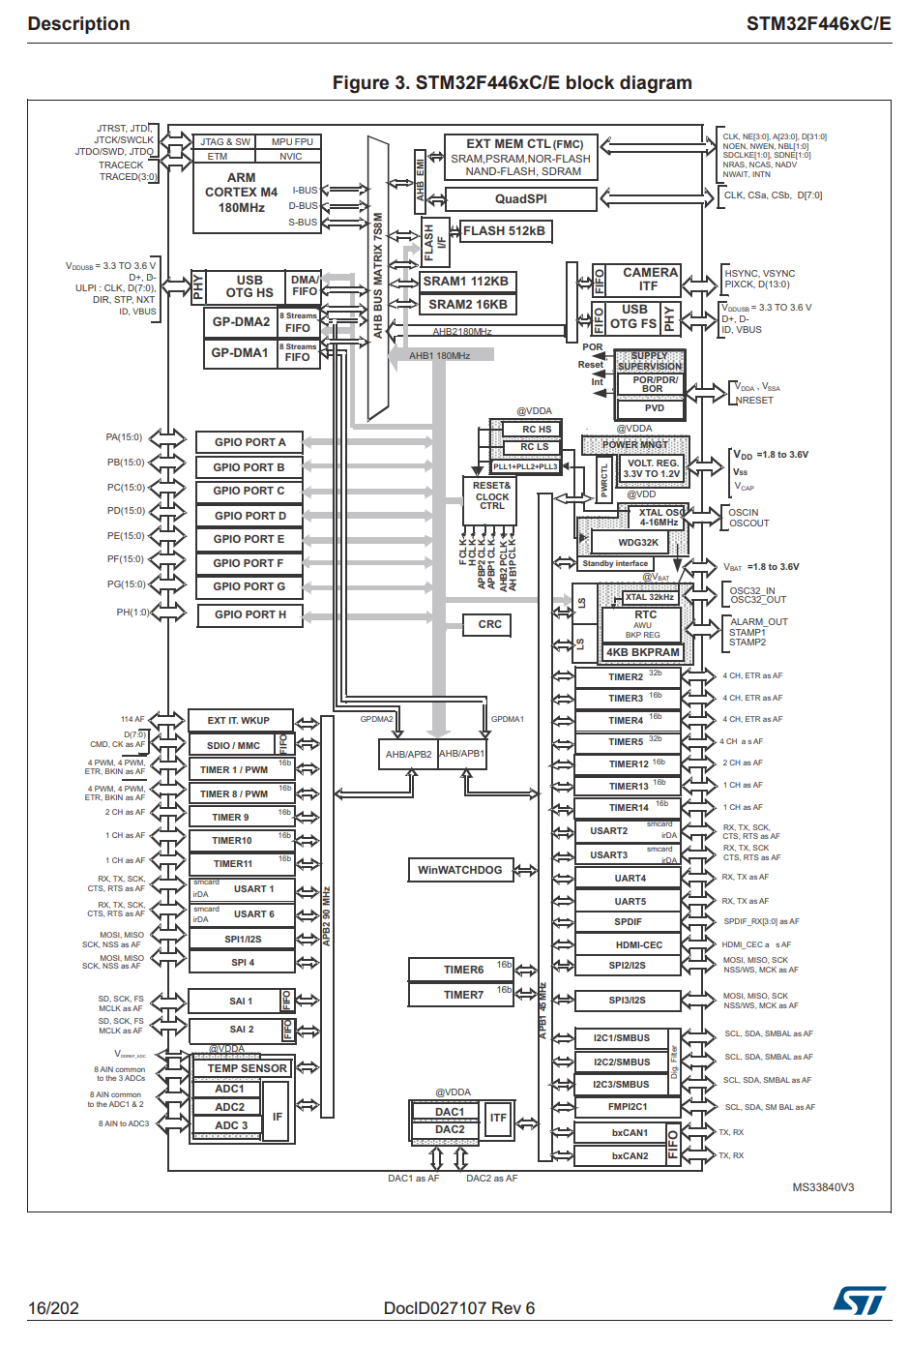

Daughter Board

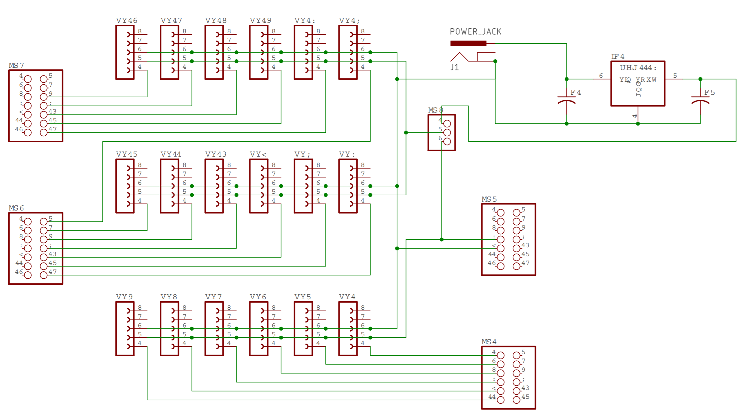

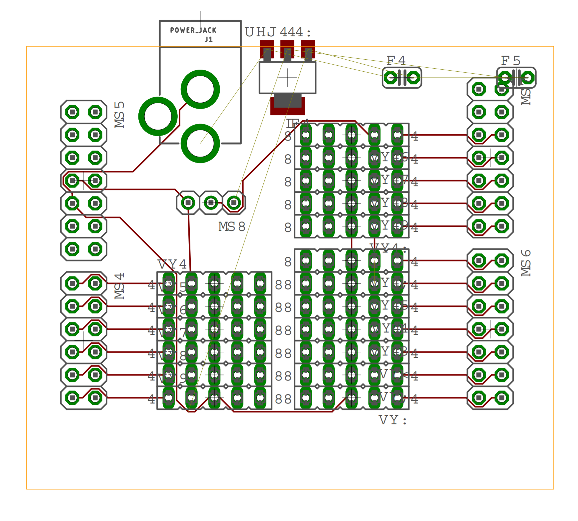

**Figure 3a**

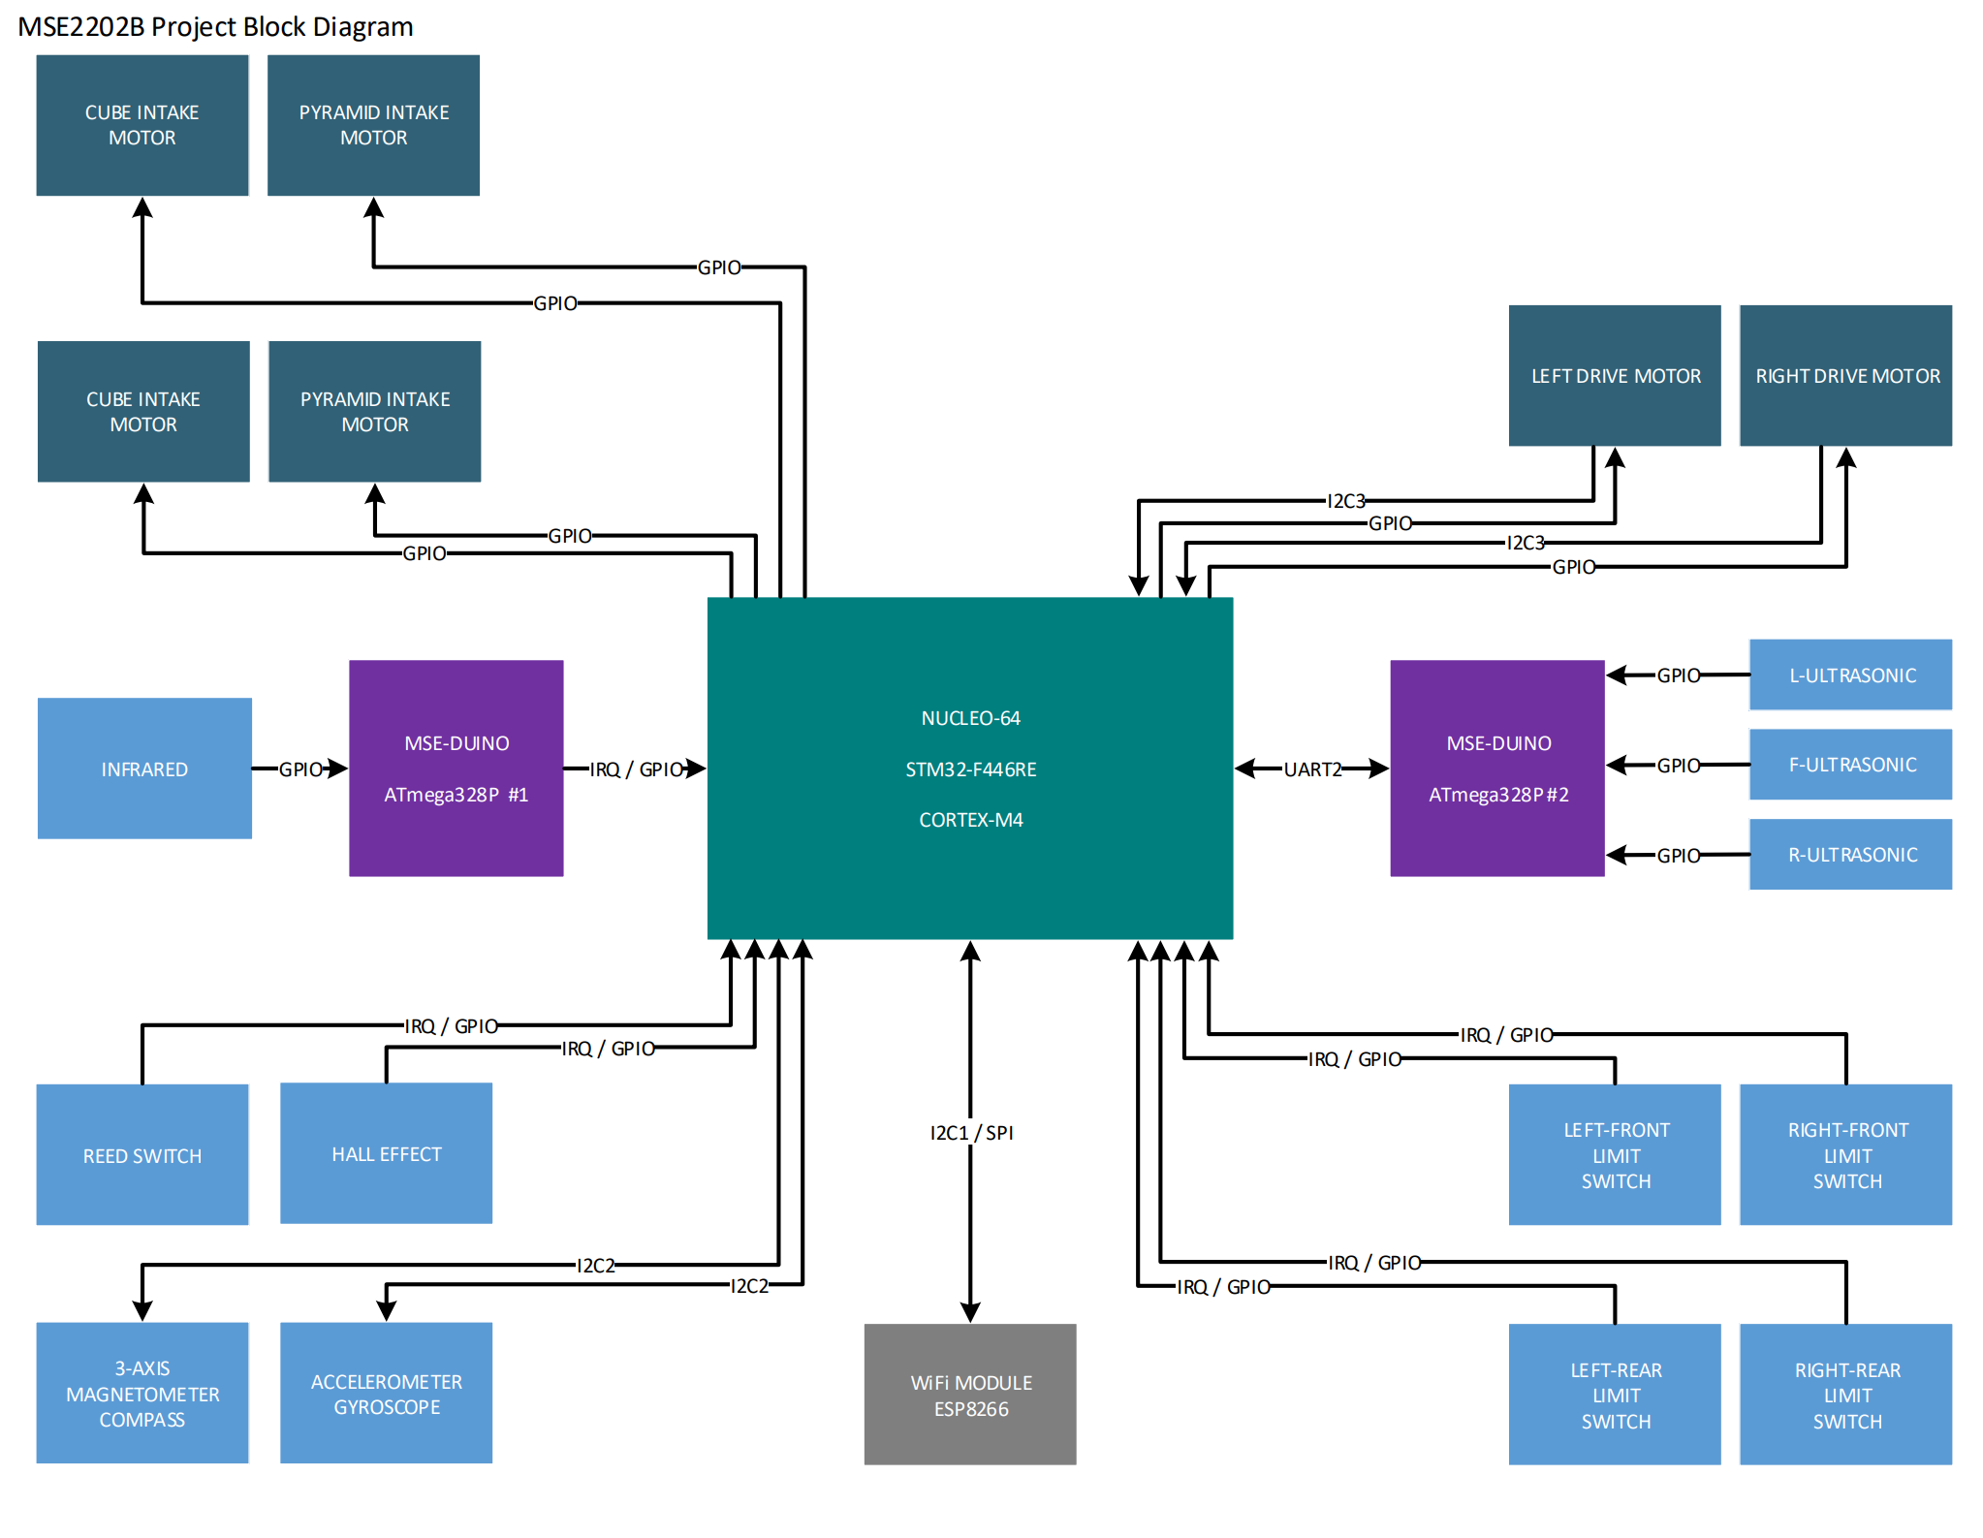

**figure 3b**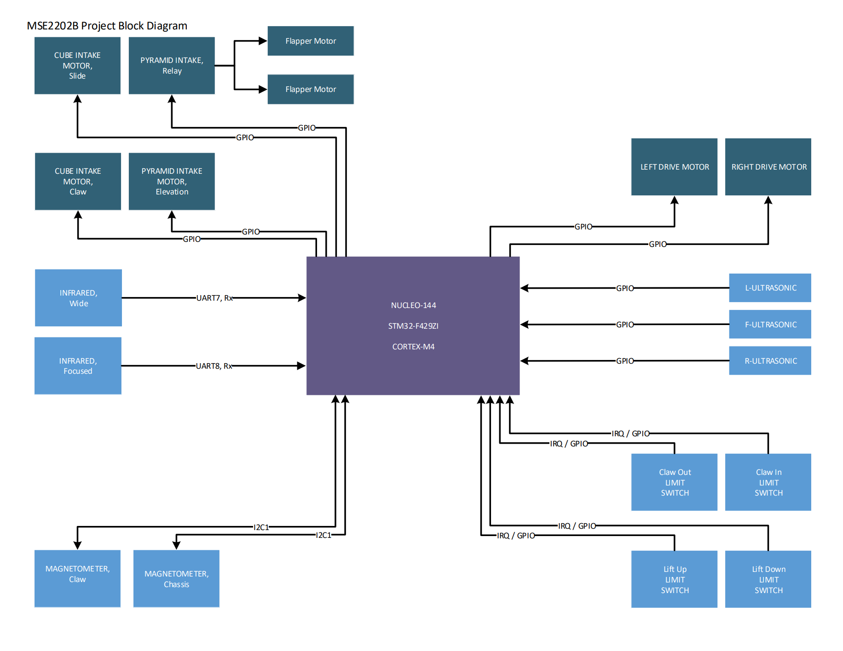

**Figure 2**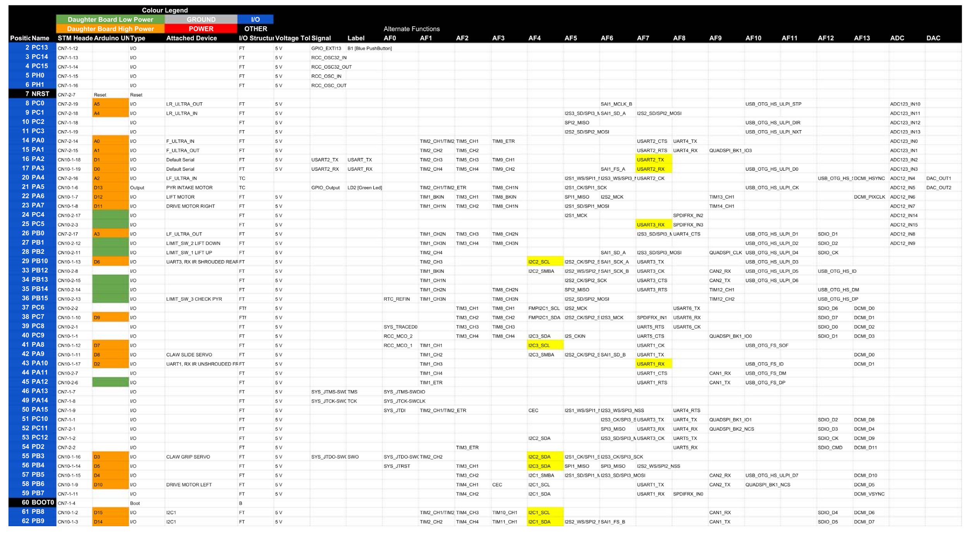

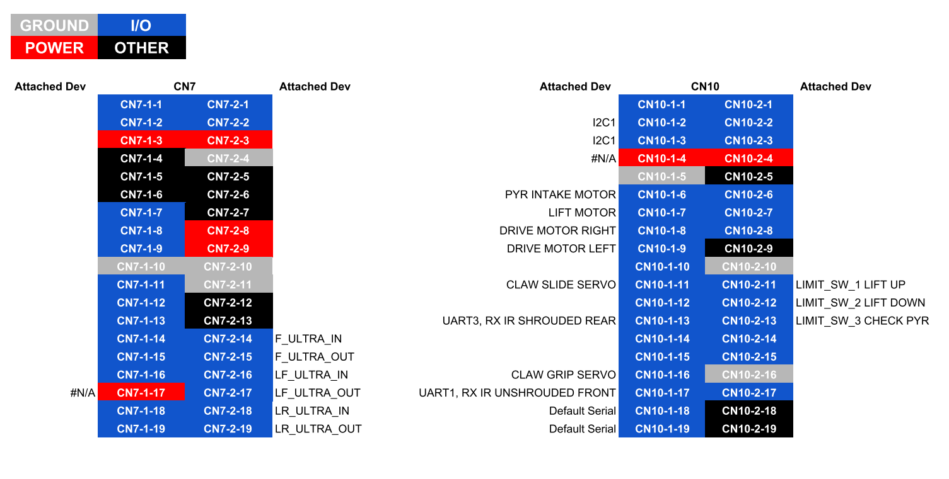

**Engineering Analysis**

**Drive**

To allow the product to successfully navigate the field and maneuver conduits with no stalling, yet fast enough speeds, a strong motor with a high torque was required. As such, the NEMA 23 2250 Position-Control DC Motor from McMaster Carr was selected for its high stall torque of 23in-oz and peak power of 320W.

To verify the motor would satisfy torque requirements, a torque calculation was done on each wheel.

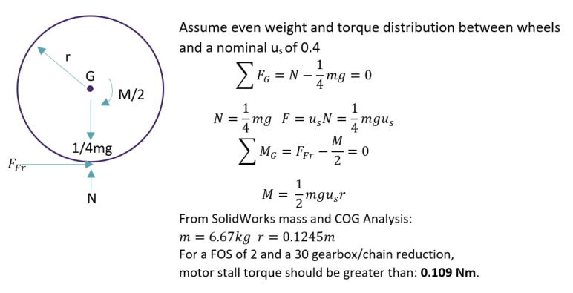

As the NEMA motors provide 0.162Nm in stall torque, these motors satisfy the torque requirement with a factor of safety of 2.

**Lift and Claw Arm**

To develop a reliable lift for the pyramid that can consistently pickup and drop the pyramid, a high torque with a large margin of safety is required. A torque analysis was done to determine the largest torque requirement from the pyramid lift.

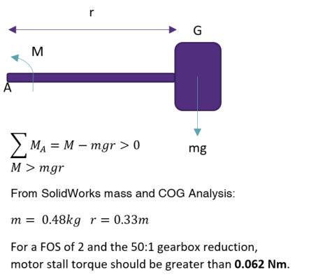

Using the NEMO 14 with gearbox from McMaster Carr, it is seen that the torque requirement is met with a factor of safety of 2, as the motor has a stall torque of 0.07Nm. The same motor was selected for the Claw Arm due to similar torque requirements.

**Pyramid Intake**

The pyramid intake uses two rollers moving in opposite directions spaced out enough to let a pyramid through. Due to this nature, size is of utmost importance, along with a high RPM and a reasonable torque. The Compact Round-Face DC Gearmotor was selected for its small size of 3.75x1.25x1.25in and high speed of 202 rpm. One of these on both sides will prevent any torque issues.

**Detailed Documentation**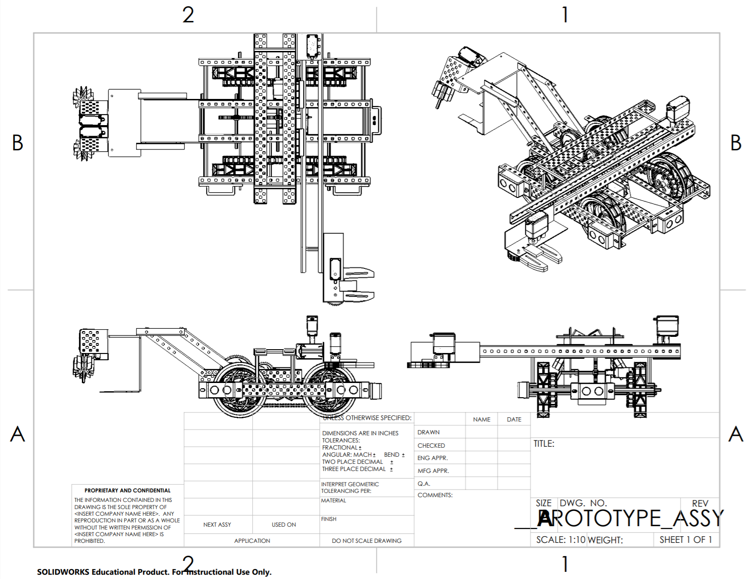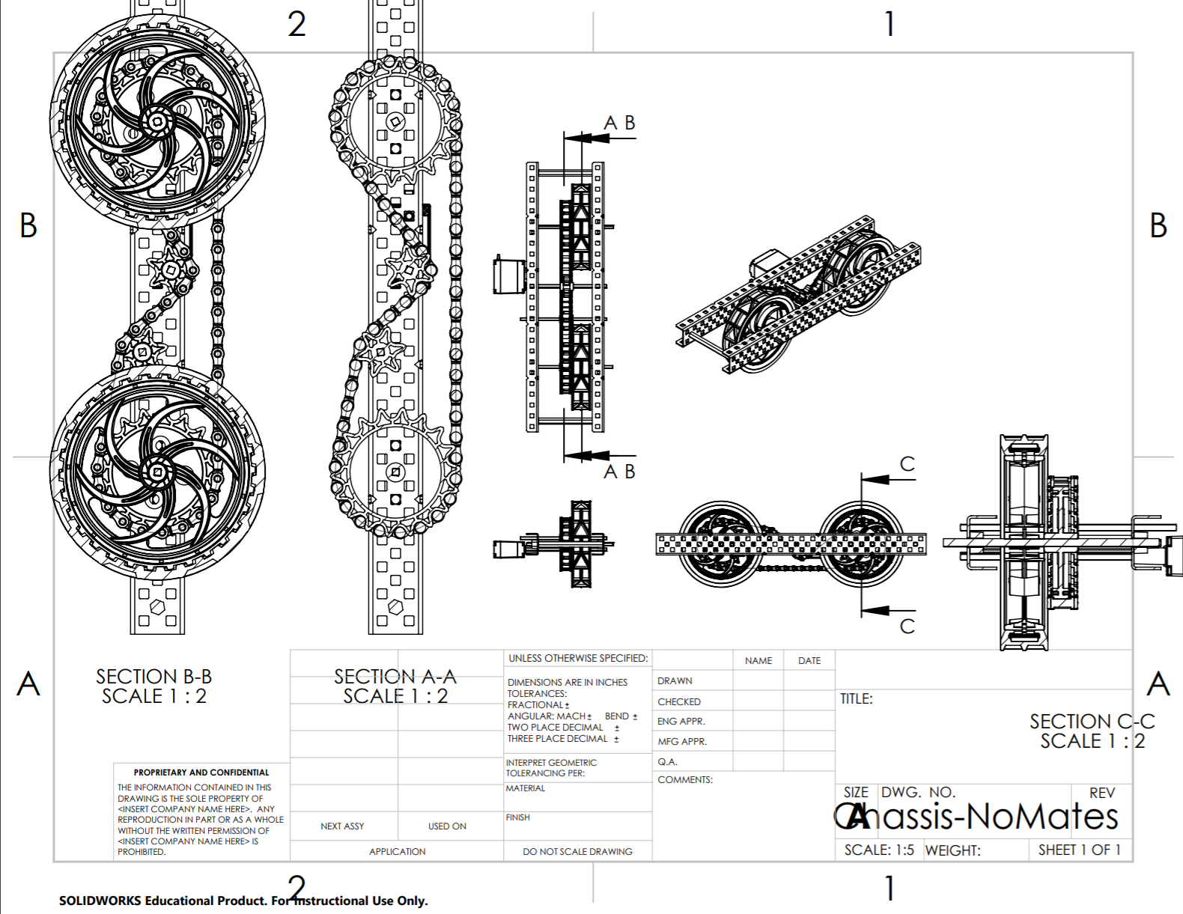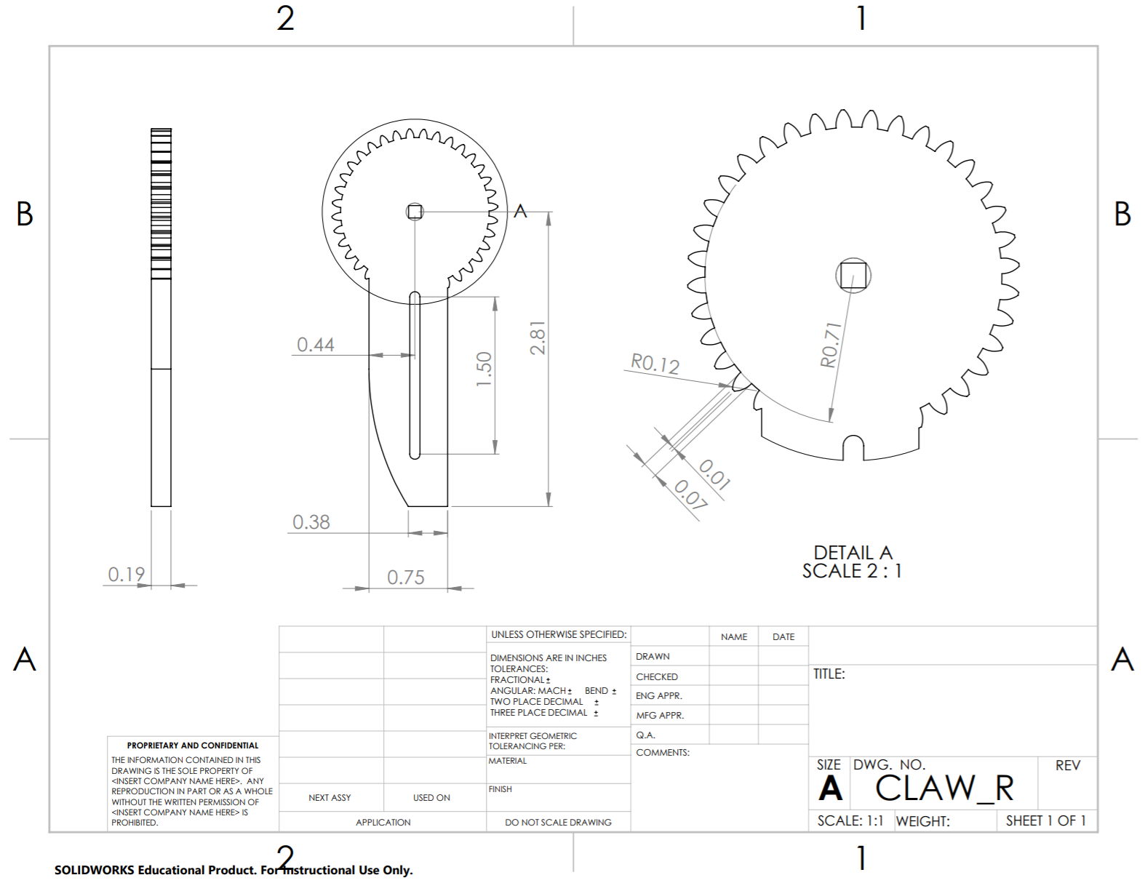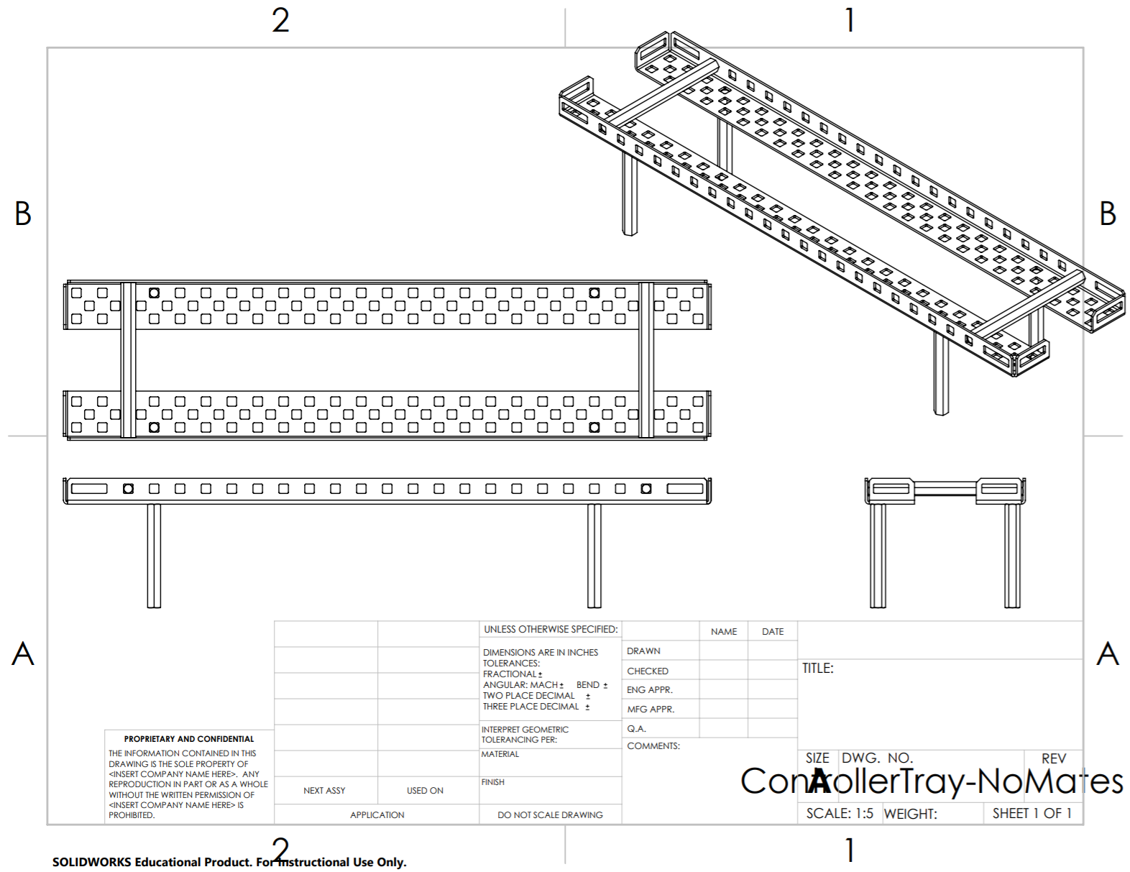

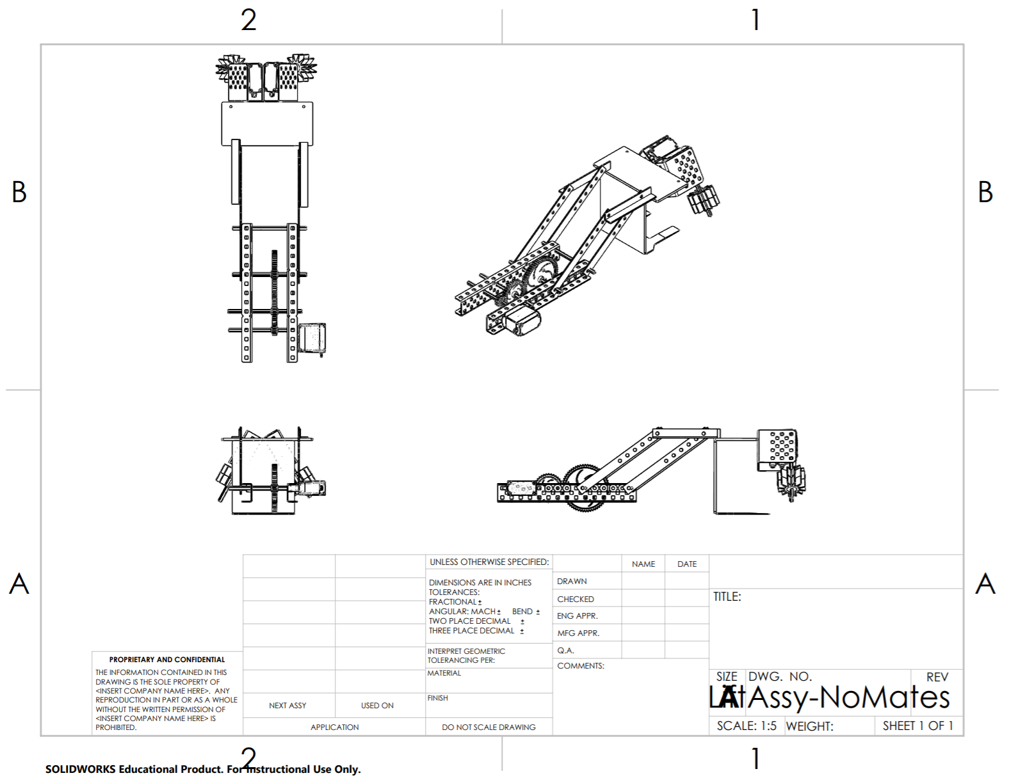

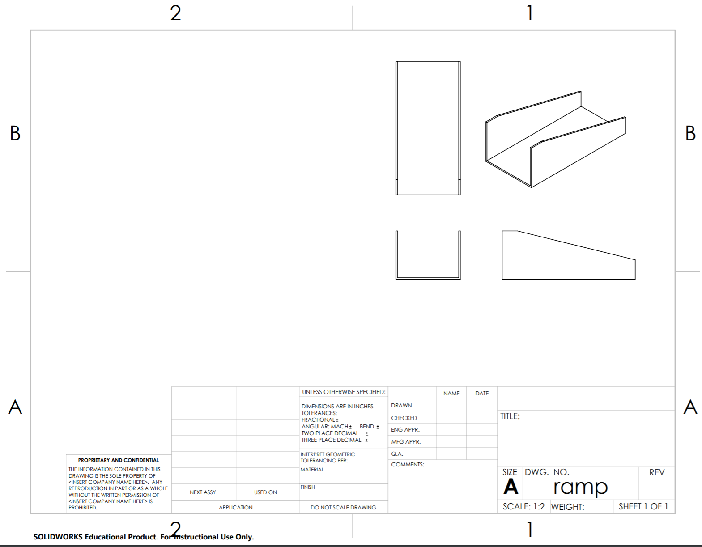

**Product BOM**

|  |  |  |  |  |
| --- | --- | --- | --- | --- |
| ITEM NO. | PART NUMBER | DESCRIPTION | QTY. | Drawing |
| 1 | ChassisSidePlate | Wheel/Motor Mount | 2 | YES |
| 2 | 6627T54 | Wheel Drive Stepper | 2 | YES |
| 3 | 60355K503 | Ball Bearing | 4 | YES |
| 4 | 1327K113 | Steel Shaft | 4 | YES |
| 5 | 2737T131 | Wheel Sprocket | 4 | YES |
| 6 | 6261K281 | Roller Chain Link | 78 | YES |
| 7 | 2737T2 | Motor Sprocket | 2 | YES |
| 8 | Wheel_Bushing |  | 4 |  |
| 9 | CasterWheel_5in.ipt |  | 4 |  |
| 10 | ChassisSideCover |  | 2 |  |
| 11 | SideSensorEntension |  | 2 |  |
| 12 | SideSensorMount |  | 2 |  |
| 13 | ChassisMotorHousing |  | 1 |  |
| 14 | ClawArmBearingMoun  t |  | 1 |  |
| 15 | 60355K509 | Ball Bearing | 1 | YES |
| 16 | ArmRotate |  | 1 |  |
| 17 | RackStand |  | 2 |  |
| 18 | 93410A912 | Threaded Rod | 1 | YES |
| 19 | 95120A592 | Flange Nuts | 2 | YES |
| 20 | Rail |  | 4 |  |
| 22 | ClawWormCoupler |  | 1 |  |
| 23 | ClawRailMotorBracket |  | 1 |  |
| 24 | 60355K504 | Ball Bearing | 1 | YES |
| 25 | ClawBracket |  | 1 |  |
| 26 | ClawMount |  | 1 |  |
| 27 | CLAW_L |  | 2 |  |
| 28 | CLAW_R |  | 2 |  |
| 29 | 6627T37 | Claw Clamp Motor | 1 | YES |
| 30 | 57545K511_SPEED-  REDUCING WORM  GEAR FOR 90 DEG  TRANSFER | Worm Gear | 1 | YES |
| 31 | 57545K527_SPEED-  REDUCING WORM  GEAR FOR 90 DEG  TRANSFER | Worm Gear | 2 | YES |
| 32 | RotationBushing |  | 2 |  |
| 33 | 6627T38 | Lift Motor, Arm Rotation Motor, Linear Slide Motor | 3 | YES |
| 34 | CubeArmMountBracke  t |  | 2 |  |
| 35 | LiftLinkageBaseMount |  | 4 |  |
| 36 | PyrIntakeAngledMount |  | 1 |  |
| 37 | PyrIntakeBacking |  | 1 |  |
| 38 | PyrIntakeForks |  | 1 |  |
| 39 | LiftLinkage |  | 4 |  |
| 40 | 2709K12 | Roller Motors | 2 | YES |
| 41 | PyrIntakeMotorMount |  | 1 |  |
| 42 | PyrIntakeRoller |  | 2 |  |
| 43 | 57545K511_SPEED-  REDUCING WORM  GEAR FOR 90 DEG  TRANSFER-cutoff | Worm Gear, Cut | 1 | YES |
| 44 | PyrIntakeLinkageRod |  | 1 |  |

**Product Evaluation**

The performance of the prototype and the product can not be equated as many of the factors that negatively affected the performance of the prototype will not be present in the actual product. This is because in spite of our best efforts several aspects of the product were not accurately replicated and represented on the prototype. For example the motors used on the prototype are much weaker that those used of the product. The motors are also bulkier which limit the space on the robot. The wheels on the prototype are also poor representations of those that were selected for the product. The 4” rubber wheels being used on the product are soft and offer much more traction than the VEX wheels used on the prototype, even with the added traction from the tennis racket grip tape.

Most of the components of the prototype functioned individually. However, our prototype had difficulty locating the correct pyramid. Testing various components and mechanisms on the robot showed that the mechanical design of the prototype was functional. Unfortunately, problems with the code and the IR sensors used resulted in inconsistent results when the robot was navigating the course.

Overall, spending more time debugging and refining the code would allow the prototype to function as intended.

The final product designed meets most but unfortunately not all of the design requirements specified by the group. The rubber wheels would allow for effective navigation of the field, however the large turn radius due to the larger size of the robot and the 4 wheel drive results in wide turns around the corners of the course which would cause the tesseract to be missed if it was placed close to a corner. The cube is picked up and held on to firmly by the claws designed due to the addition of the grip material as required by the specifications stated at the beginning of the project. Finally, the intake used for the pyramid was proven to be able to pick up the pyramid from different angles as long as the bottom of the forklift intake is at a 10 degree incline and the intake is free to open up more when the pyramid is being picked up from it’s wide side. The addition of the elastics to the intake also allows the wheels to apply enough force to the pyramid to intake it when it is being picked up from its thinner side. Finally, the product might take longer than three minutes to complete the task depending on the location of the pyramid due to the fact that the IR sensors have around a 2 ft effective range so the robot must navigate the field looking for them. .

To ensure that the product is consistently meeting all requirements when in the field, the code must be refined to include safety checks incase a step is not completed properly. Aspects of the code must also be debugged to ensure that locating the correct pyramid is done is consistently, no matter the location of the pyramid.

**Cost of External Parts sourced for Prototype**

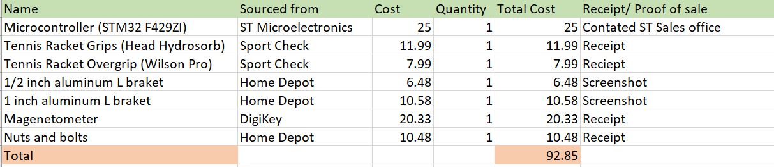

**Sourcing of External Parts**

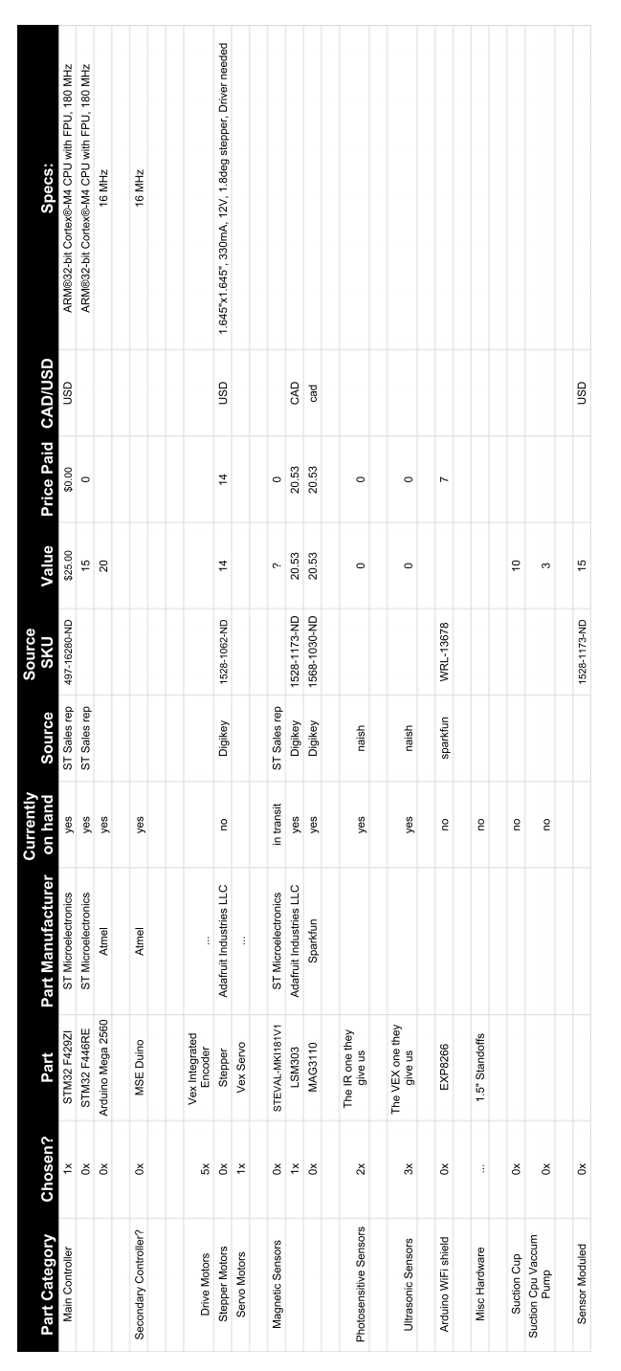

**Receipts**

